So, what is sensory play?
Picking things up and feeling their texture is what people often associate with sensory play, but it’s about much more than touch.
Sensory play includes any activity that stimulates a young child's senses of touch, smell, taste, sight and hearing, as well as anything which engages movement and balance.
Sensory play is only really limited by your own imagination, with of course some common sense being used around the materials and types of play appropriate for your child’s age and ability.
Some examples to get you started are:
- Sensory play for babies – watching bubbles float and feeling them land on their skin, or scrunching coloured paper to hear the noise, feel the contours and see the shapes change
- Sensory play for toddlers – observing light and shadow created by torch light on objects of different shapes or sizes, or watching the colours mix and the patterns form by finger painting or sponge painting (with child-safe paint)
- Sensory play for pre-school aged children – creating shapes and playing with kinetic sand, or playing with musical instruments and listening to the tone and pitch as they strike or blow through instruments softly or forcefully
Probably the simplest way to help children engage their senses is by playing outside with nature, full of colours, movement, textures, sounds and smells.

The benefits of sensory play
With sensory play, there’s always much more going on than meets the eye.
Sensory activities, in addition to being fun and interesting for babies and young children, encourage children to explore and investigate. Furthermore, these activities support children to use the ‘scientific method’ of observing, forming a hypothesis, experimenting and making conclusions.
Sensory activities also allow children to refine their thresholds for different sensory information, helping their brain to create stronger connections to sensory information and learn which are useful and which can be filtered out.
For example, a child may find it difficult to play with other children when there is too much going on in their environment with conflicting noises or sights.
Through sensory play, the child can learn to block out the noise which is not important and focus on the play which is occurring with their peer.
Another example is a child who is particularly fussy with eating foods with a wet texture such as spaghetti. The use of sensory play can assist the child with touching, smelling and playing with the texture in an environment with little expectation. As the child develops trust and understanding of this texture it helps build positive pathways in the brain to say it is safe to engage with this food.

Here are some ideas that you may be able to recreate at home, these are just some of the things you can do and you really can use your imagination. Have fun, get messy and creative.

Please use your own judgment while recreating any of these activities, you know your child and what is suitable, please supervise if you are worried your child may eat non- food items.

Bath painting | 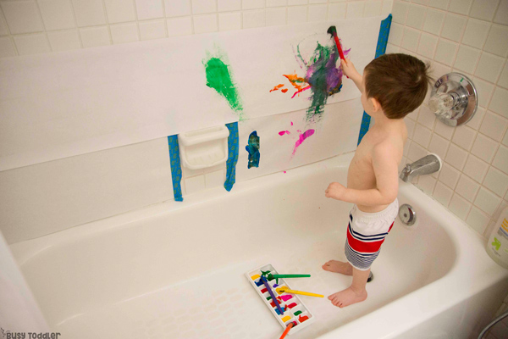 | Sometimes it can be hard to contain the mess of paint, so mixing paint and bath time works perfectly. Making sure you use washable paints, you can let them paint the inside of the bathtub during bath time, when finished you can get them to help clean with a bubbly sponge as well as cleaning themselves! It keeps them entertained and it contains the paint to one area.  You don’t need paintbrushes if you don’t have any don’t worry, let them explore the paint with their hand’s feet etc, if you don’t have paint you may have some of these ingredients to make some homemade paints instead.  -Shaving foam mixed with food colouring  -Corn flour mixed with liquid soap, water and food colouring.  Just be mindful that food colouring could dye grout/bathroom sealer so use very small amounts of dye!
Ice play | 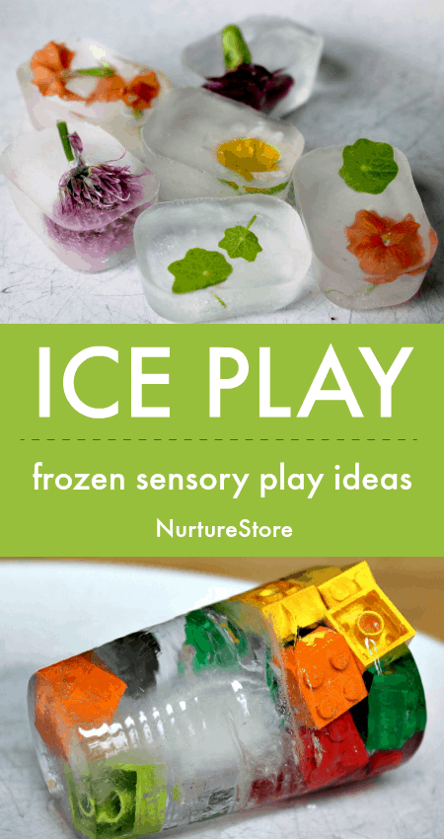 | So simple to use everyday containers and with interesting items, and fill with water and pop into the freezer, you could use this opportunity to go outside and find flowers and other natural materials together and put them into containers. Talk about the properties of water and what happens when we put it into the freezer, how it melts when we get it out etc!  On a hot day you can add lots of ice cubes to water play to help cool.
Shaving foam | 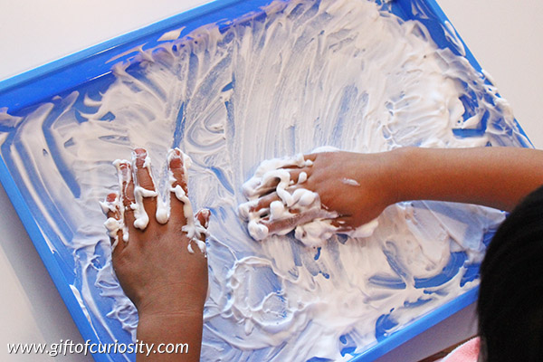 | You may have this around the house if not, usually own brand essential shaving foam is the best, shaving gel doesn’t work as well. You can add paint, glitter, oils have a play around. This is a great one to practice making lines, shapes, letters etc with your fingers.
Bubble play | 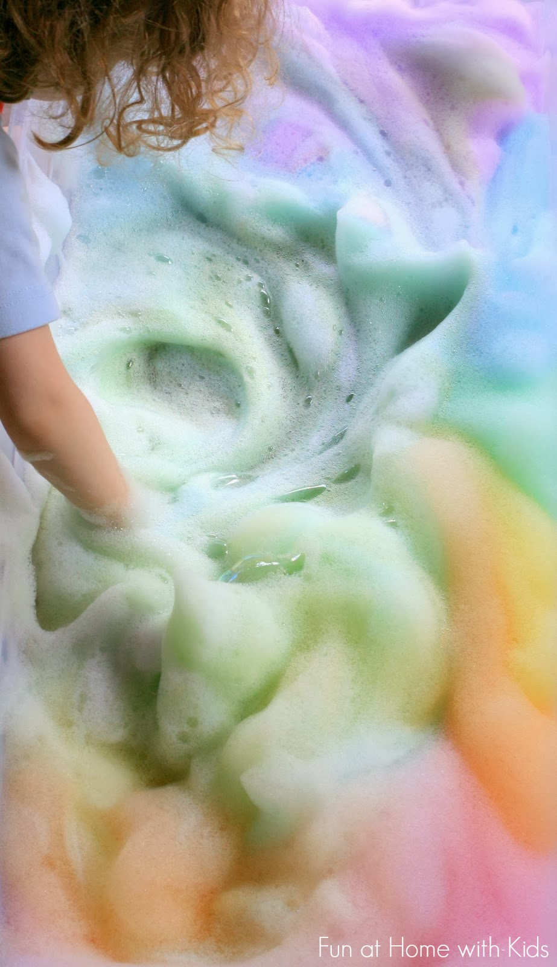 | If you have an electric mixer you can make some foamy bubble mix to play with, this feels silky soft and can be very calming, again add colours essential oils as you like to make the experience go further. You could add small toys and use this as a scene to play in
Mud Kitchen | 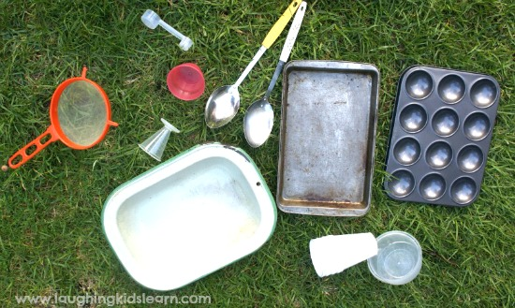 | Mud  If you’re lucky enough to have an outdoor space you may have an area of soil, you could set up a really simple mud kitchen, I’ve attached some Pictures for inspiration, this is a great activity  and you can go as far as you like and you can add lot of different items and role play with this, use muffin trays, bowls, spoons, mud, stones, shells, sand, grass, flowers, bark etc.
Paper | 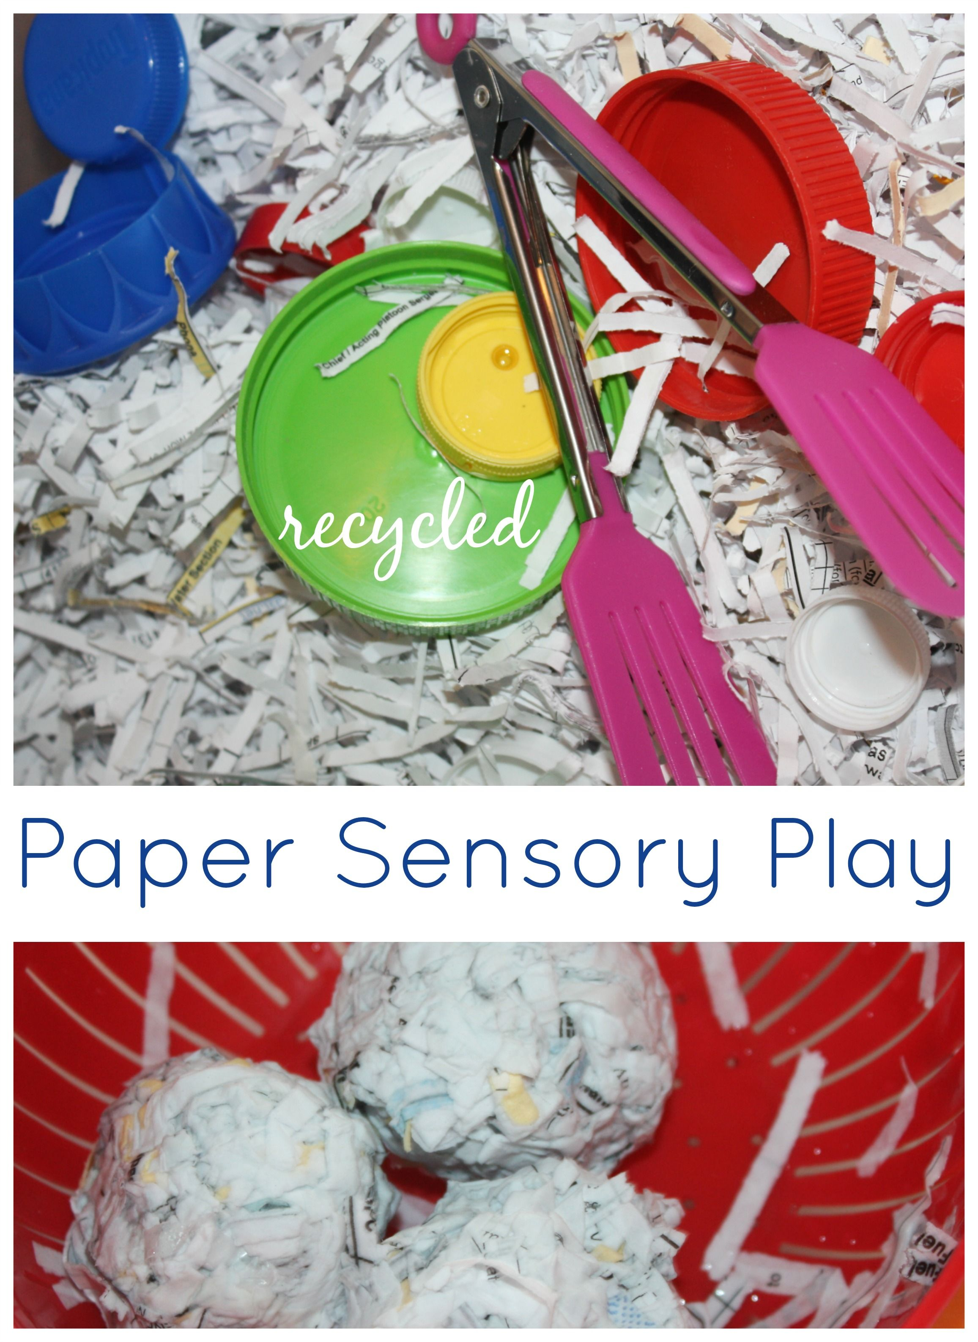 | Dried or wet, there are so many ways to play with paper, you can use old newspaper or junk mail. You don’t need anything fancy.  You could try ripping it, shredding it, adding water. Use different types of paper to get a different sensory experience, toilet roll, kitchen roll etc.  If you have older children, they could research how to make paper from recycled materials at home which can also be a fun activity too use any left-over materials
Pasta  Dried or Cooked | 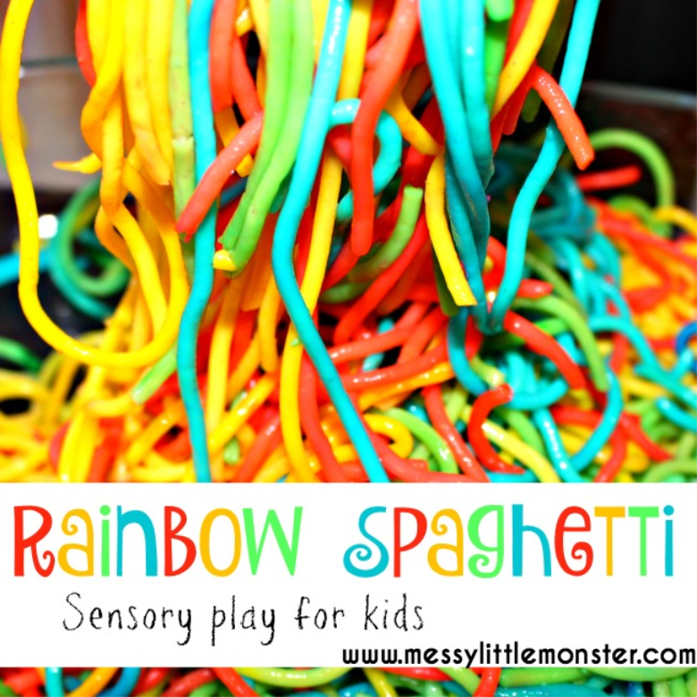  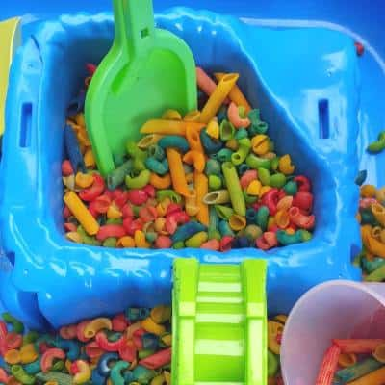 | Dried  This is a pouring activity, any type of pasta will do, pour a small amount into a flat container  With sides add containers, spoons and other items found around the home. ( we sometimes use this in our role play kitchen as ‘food’ )  Cooked  You might have some left-over spaghetti, this can make an interesting sensory experience, you could add food colouring etc
Corn Flour Gloop | 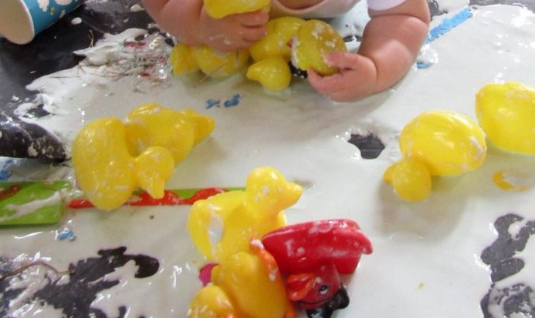 | Corn flour mixed with water makes an amazing play experience. It can get a little messy so best done in an area that’s easily cleaned.  Mix corn flour and water to create a gloop. This is easiest to clean when it’s dried because you can sweep it up!
 | 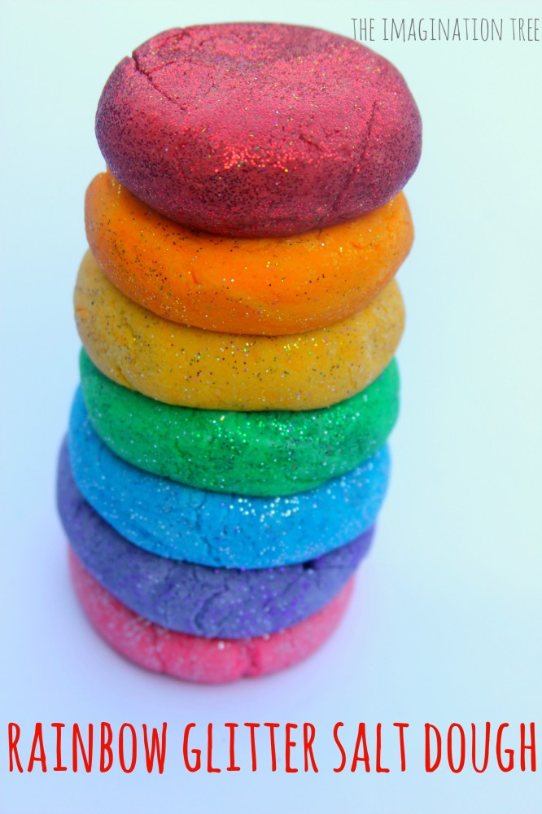 | Play dough  Lots of you may already have pots of play dough at home but it’s also incredibly easy to make  At home, this can be a lovely activity to do together and you most likely have all the ingredients at home. Once you have made this and it’s cooled down a little it’s lovely to let them play with it warm. You can use cookie cutters (cups work fine if you don’t have cutters but you can use lots of items from around your home to make imprints in the dough that are just as effective)  - 2 cups plain flour (all purpose)  - 2 tablespoons vegetable oil (baby oiland coconut oil work too)  - 1/2 cup salt  - 2 tablespoons cream of tartar  - 1 to 1.5 cups boiling water (adding in increments until it feels just right)  - gel food colouring (optional)  - few drops glycerine (my secret ingredient for stretch and shine!) (optional)  Method:  Mix the flour, salt, cream of tartar and oil in a large mixing bowl  - Add food colouring TO the boiling water then into the dry ingredients  - Stir continuously until it becomes a sticky, combined dough  - Add the glycerine (optional)  - Allow it to cool down then take it out of the bowl and knead it vigorously for a couple of minutes until all of the stickiness has gone. * This is the most important part of the process, so keep at it until it’s the perfect consistency! *  - f it remains a little sticky then add a touch more flour until just right  - https://youtu.be/SMw41MyD0Sk
Cloud Dough | 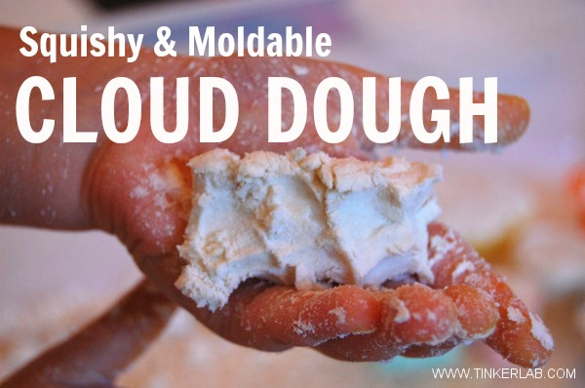 | This is a different type of dough to play dough, it’s powderier and not as pliable but it’s so tactile, again you can add different food dye/ essential oils to this to make it more exciting sensory experience if you like.  8 cups flour  - 1 cup oil  - Scoop and pour the flour into the centre of a large tub.  - Create a crater in the middle of the flour.  - Pour the oil into the crater.  - Gently mix it all together.  - Enjoy mixing and learning about the properties of the dough  - as it is, or add small silicone bowls, spoons, or measuring cups to make small structures, hills, or pretend cupcakes
Water pouring station | 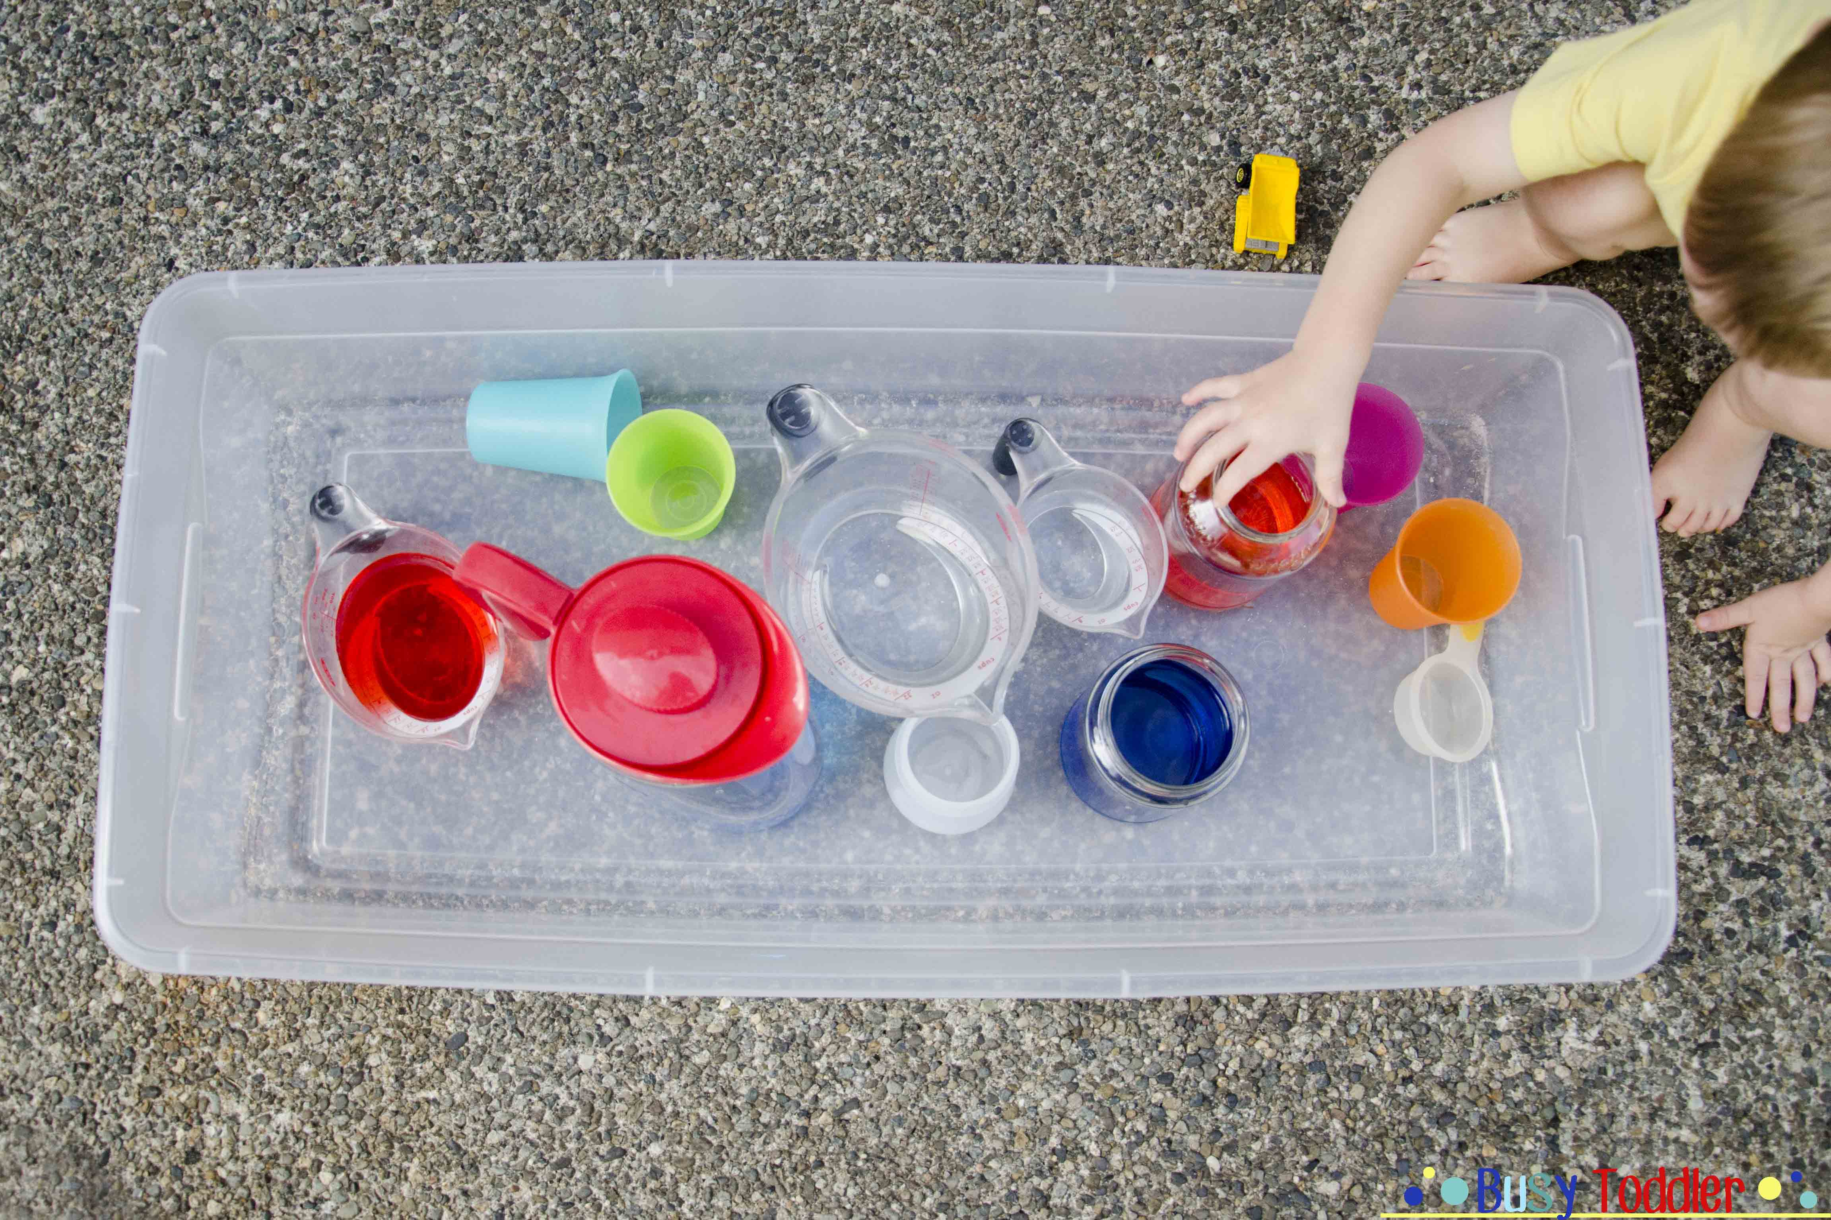 | Make a pouring station outside  ( or if you’re brave enough inside) use cups, jugs, sieves, tubes, You can use things like food dye, bubbles or essential oils to make this more interesting, you can add ice cubes, flowers and other interesting items that you might find around your home, this is perfect for those hot days!
Pouring  Rice/ lentils | 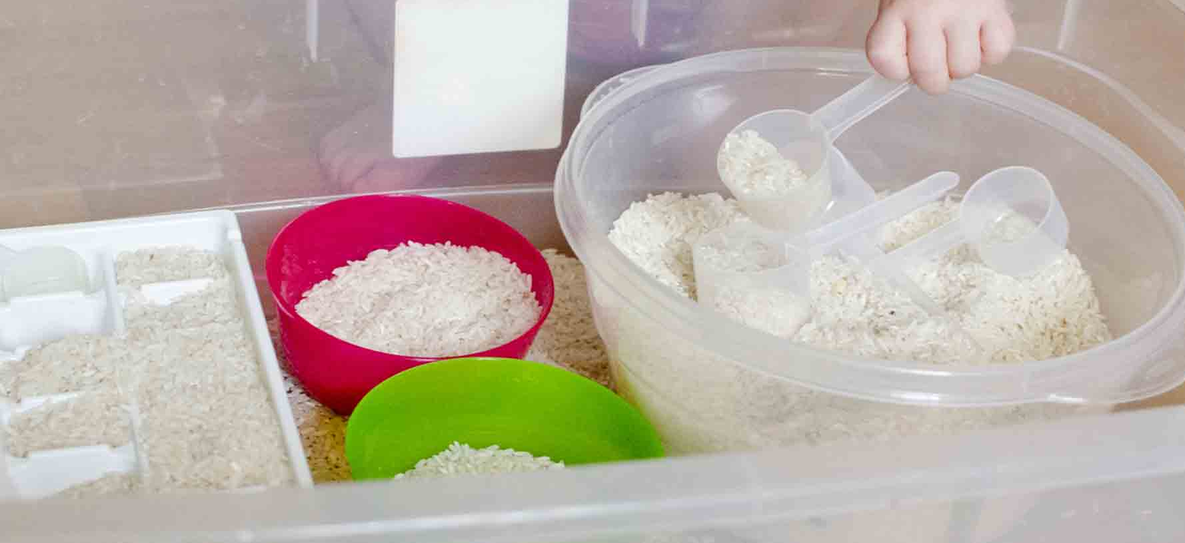  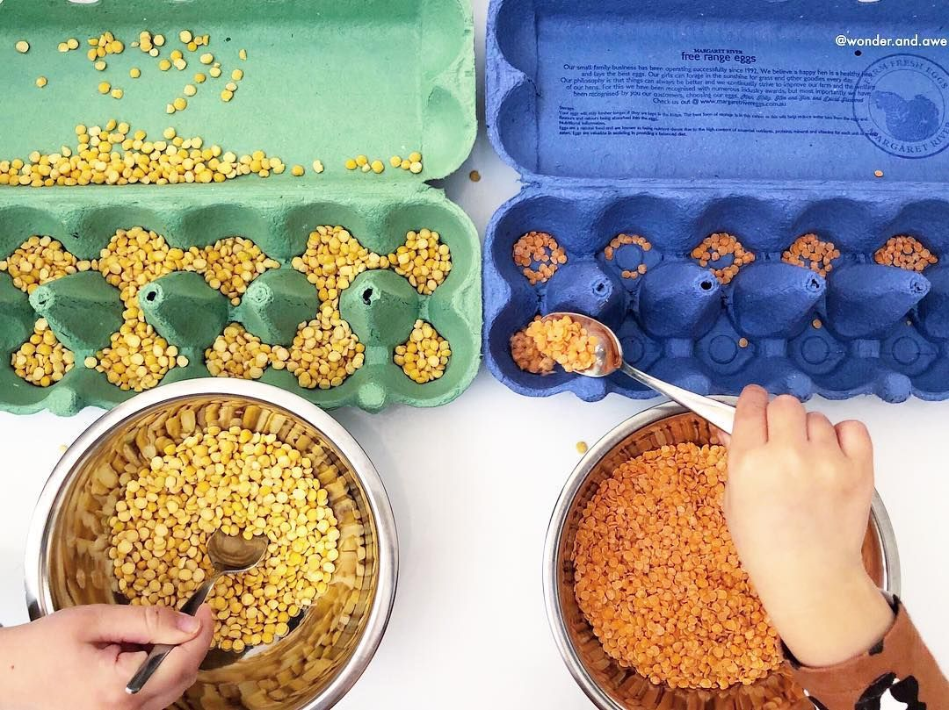  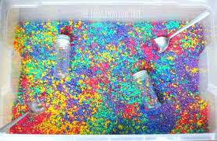 | Simply pour an amount into a tray, add cups, spoons, measuring cups, bowels, whisks etc  If your child likes this but gets a little bored you could try dying the rice a different colour  which is very easy, add rice into a food bag with a pump of hand sanitiser and food colouring,  Shake or mix inside then pour out of the bag into the tray then leave to dry for an hour or so. You could try adding a few drops of essential oil to add to the sensory  Lentil play  As with the rice lentils are a lovely for pouring and can be a super calming activity for adults and children!  After use I store any dried rice/lentils in an airtight container for next time. You can add a bit of hand sanitiser to keep it clean in-between uses, but use your own judgment and always inspect before use.
Sensory bottles | 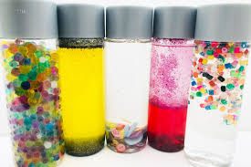 | These are so much fun. Add different things to the bottles to create noise, such as rice or dried beans. You could add water beads, Oil and water, buttons, you could also add items that smell such as lemon, essential oils or perfume, flowers, herbs, spices etc and see if they can guess what is inside

