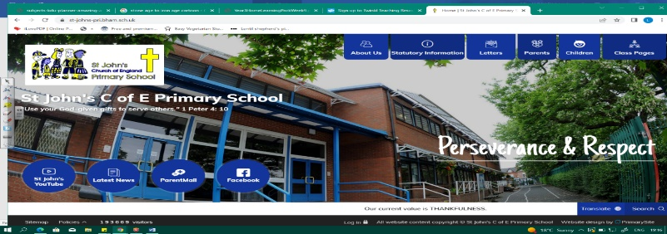
Environmental Engineers
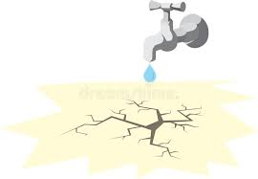
During this unit, we will develop our understanding of water from our previous unit (Wild Water). However, now we must look at the uses of water, where we get our water from and the problems of water distribution around the world.

We will examine Birmingham’s problems with water in the past and how they were solved. This will prepare us for learning about the Industrial Revolution in Year 6. We will focus our study on how the charity Water Aid is helping developing nations and consider our role as responsible global citizens.
Can you answer these questions at the end of this unit?
Geography
- How do we measure rainfall and water? What does the term water stress mean?
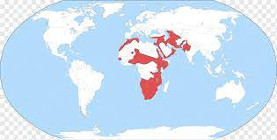
- Why is water essential to life? What problems do people experience if they don’t have access to clean water?
- Where in the world are there areas of water stress (show countries on a world map)? How is life there different to life in Birmingham?
- Where does our water come from? Describe the process it goes through to get to our taps?
infrastructure | water distribution | reservoir | sewage |  | shanty town |  | water aid
developing country | overcrowding | overpopulated |  | water stress |  | natural resources
Key Vocabulary (Tier 3)

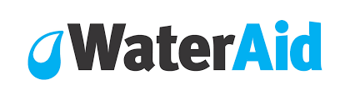
English
We will study visual text The Cloud That was Made of More and look at personification and descriptive language. We will also look at Water Aid adverts, explore use of emotive language and then write a letter to the government to support the finding of water supplies in Africa.
blazing | thirst | scorching | beat | drought | billowing | cascade
Key English Vocabulary (Tier 2 and 3)

