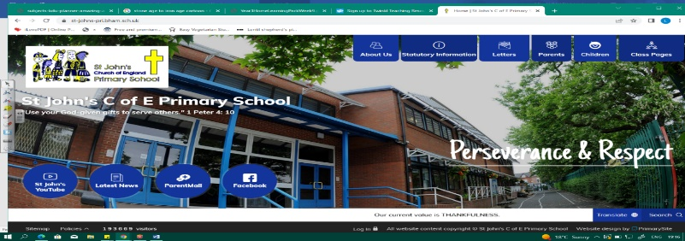
Wild Water
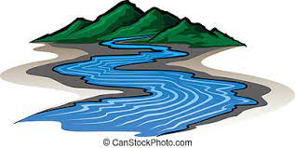
During this unit we will learn about some of the world’s most famous rivers and where they are found, features of a river and why people settle near them. This will prepare us for studying the River Avon in Year 5 and the Nile in Year 6.
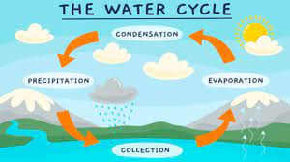
As scientists, we must consider the water cycle and states of matter. We will classify animals and reflect on how humans have damaged their habitats. Our understanding of climate change and the affects on our world will also deepen during this unit.
Working Scientifically During this unit, we can improve our skills in:
- planning different types of scientific enquiries to answer questions, including recognising and controlling variables where necessary.  - recording data and results of increasing complexity. | - using test results to make predictions to set up further comparative and fair tests.  - reporting and presenting findings from enquiries, including conclusions, causal relationships and explanations of and a degree of trust in results.
Can you answer these questions at the end of this unit?
Geography  - Geographers study physical processes. Why is this important?  - Can you name some famous world rivers? Show on a map.  - How long is the longest river in the world?  - Which countries does it span?  - Describe some physical features of a river.  - Why do people tend to settle near large rivers? |  | Science  - How have humans damaged animals’ environments?  - Can you group animals into vertebrates and invertebrates?  - Describe the water cycle
classification keys |  | amphibians |  | reptiles |  | mammals | states |  | evaporation | condensation
human impact | river source |  | tributary |  | meander |  | delta | river mouth |  |  | OS map
Key Vocabulary (Tier 3)

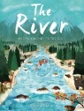
English
We will read The River: An Epic Journey to the Sea by Patricia Hegarty to focus on explanation texts. We will study a range of stories about journeys before writing our own story about a fish’s journey.
frolic | shimmer | determined | immense | emerge | dappled | glints | drench
Key English Vocabulary (Tier 2 and 3)

