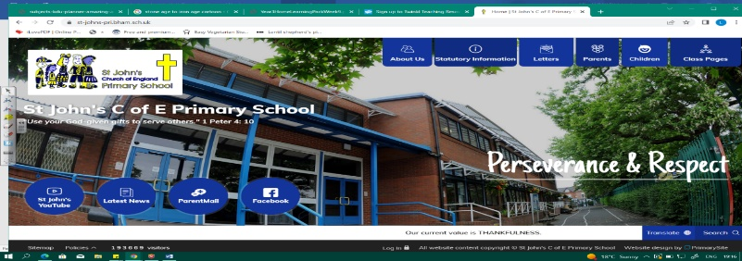
Super Sonologists
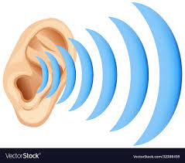
During this unit, we will become sound engineers! We will investigate how sound is made, how it travels to the ear and vibration strength. We must conduct experiments to find out how sound changes with distance and how sound can affect recovery after exercise.
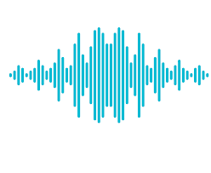
We also become skilled at using scientific equipment to record the volume of a sound. Our music sessions will be key to investigating how different instruments make air vibrate to produce sound.
Working Scientifically
During this unit, we can improve our skills in:
- setting up simple practical enquiries, comparative and fair tests.
- reporting on findings from enquiries, including oral and written explanations, displays or presentations of results and
conclusions.
- using results to draw simple conclusions, make predictions for new values, suggest improvements.
- making systematic and careful observations and, where appropriate, taking accurate measurements using standard units, using a range of equipment, including thermometers and data loggers.
Can you answer these questions at the end of this unit?
Science  - How is sound made?  - What happens to the volume if the sound is made far away?  - What causes the volume to be loud? | - What equipment did you use to measure the volume of a sound?  - What is sound measured in?  - How did you make it a fair test?
sound | vibrating | vibration | pitch | patterns
volume | louder | fainter | medium |  | travel
Key Vocabulary (Tier 3)

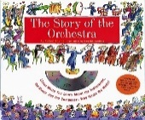
English
We will read The Story of the Orchestra by Robert Levine and study presentation and layout of a non-fiction text, before going on to write our own explanation text about an instrument.
pitch | compose | volume | dynamics | high | low
loud | quiet | vibration | length | era | yowling
Key English Vocabulary
(Tier 2 and 3)

