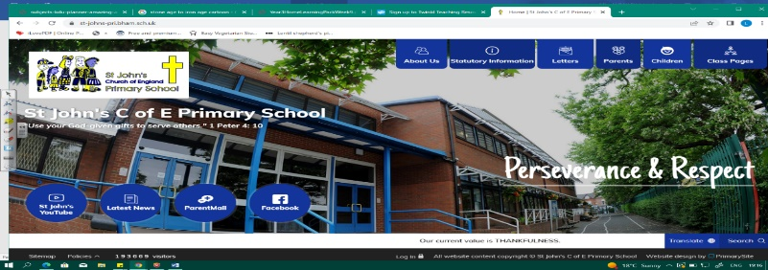
Electrical Engineers
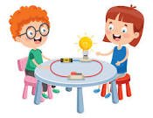
During this unit, we will become experts on physics and electricity! We will expand our scientific skills by exploring circuits, switches, conductors and insulators. We must devise fair tests, record results and draw conclusions. We will come to understand the importance of electricity in our daily lives and also its dangers.
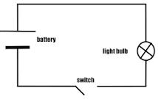
Our studies will not only give us the tools we need during our DT Project (making a game for KS1 children), they will also help us as we study electricity again in Year 6.
Working Scientifically
During this unit, we can improve our skills in:
- setting up simple practical enquiries, comparative and fair tests.  - recording findings using simple scientific language, drawings, labelled diagrams, keys, bar charts, and tables | • identifying differences, similarities or changes related to  simple scientific ideas and processes.  • using straightforward scientific evidence to answer  questions or to support findings.
Can you answer these questions at the end of this unit?
Science  - Why do we need to be careful when using electricity?  - Why are plugs covered in plastic?  - How did you make this experiment a fair test? |  | - When you tested the conductors, did you find that they had any similar properties?  - How do I make a bulb light up?  - Can you name 3 insulators and 3 conductors?
series | circuit | cells | wires | bulbs | switches |  | buzzers
loop | conductors | insulators | metals | components |  | electrical
Key Vocabulary (Tier 3)

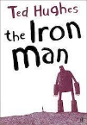
English
We will read The Iron Man by Ted Hughes, create character descriptions and then retell part of the story.
brink | swayed | patch | snag | peeping | peering | craned
Key English Vocabulary (Tier 2 and 3)

