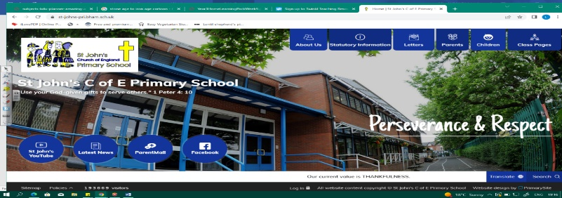
Raiders
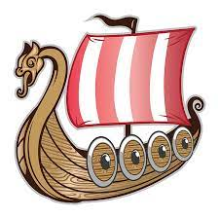
During this unit, we will discover who the Vikings were, where they came from and the legacy they left in Britain. Our Year 3 knowledge about the Romans and the Anglo Saxons will be important in how we understand this period. We will begin to see how evidence and historical interpretation can change image of Vikings as bloodthirsty raisers. We will become skilled geographers as we look at settlement, maps, migration and trade.
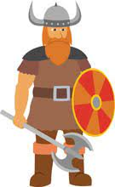
Our learning in about Vikings and Anglo Saxons together in Year 4 helps us to see the period as one and the complexity of life in Britain under both groups. This will be significant as we learn about the Islamic Golden Age in Year 5.
Can you answer these questions at the end of this unit?
History  - Who were the Vikings, where did they come from? When and why did they invade?  - Who was living in Britain at the time of the first invasions?  - What was life like in Danelaw? How do historians know?  - How have recent excavations changed our view of the Vikings? | Geography  - Which countries did the Vikings come from?  - Where did they first land in the UK?  - What is trade? Where did the Vikings go to trade?  - Why did the Vikings emigrate and invade?  - What were the Vikings looking for in a settlement? Why? How were they different similar to Anglo Saxon/Roman?
Medieval | Middle Ages |  | Dark Ages | plunderer | power struggle | unjust
danegeld | Danelaw | legacy | settlement | Scandinavia | population density | agriculture
Key Vocabulary (Tier 3)

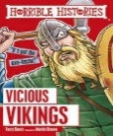
English
We will read Horrible Histories Vicious Vikings, make notes and then use these to write our own information texts. We will then read Viking sagas and retell one of these in our own words.
vicious | raid | brandish | conquer | warrior | plunder | honour
Key English Vocabulary (Tier 2 and 3)

