
Junior Medics
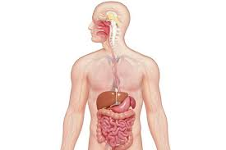
During this unit, we will build on our knowledge from learning in Year 1 about our bodies and classifying different animals. We will explore links between teeth and digestion in humans and animals, as well as investigate how food chains work.
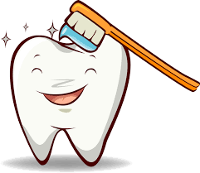
In our study of teeth, we will learn about names, descriptions and teeth in animals.
We will design an experiment to investigate damage that can occur in the enamel of our teeth and consider ways to prevent this.
Working Scientifically
During this unit, we can improve our skills in:
- asking relevant questions and using different types of scientific enquiries to answer them.
- setting up simple practical enquiries, comparative and fair tests.
Can you answer these questions at the end of this unit?
Science  - How can you classify animals by looking at their teeth?  - What are the different types of teeth?  - How can you look after your teeth? | - If an animal is herbivore, which teeth would it have?  - Can you describe a food chain, starting with a mouse?  - What is the effect on the food chain if one part is damaged?
function | digestive system |  | mouth |  | tongue | teeth | oesophagus |  | stomach |  | small large intestines
molars | canines | incisors |  | carnivores |  | omnivores |  | herbivores |  | prey |  | predator | producer
Key Vocabulary
(Tier 3)
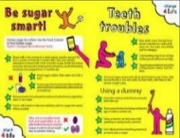
English
We will read NHS oral health leaflets to help us to study persuasive language. We will then go on to write our own leaflet to persuade people to take better care of their teeth.
experts | vital | cavity | essential | undeniable | decay | reduce | increase | crucial
Key English Vocabulary (Tier 2 and 3)

