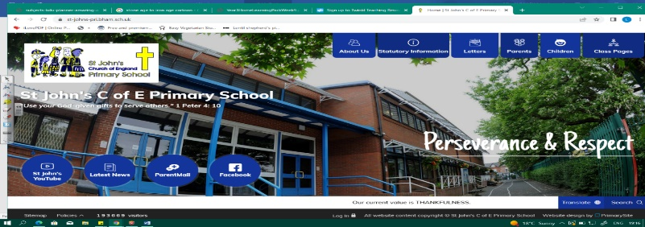
Treasure Seekers
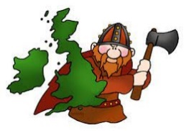
During this unit, we will build on our Year 3 knowledge of British history before 1066. We will use our understanding of the Celts and Romans, as we learn about the Anglo-Saxon legacy in Britain. As we discover who the Anglo Saxons were, when and why they settled in Britain, we will become skilled geographers by studying maps and migration.

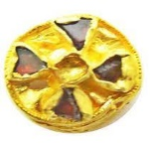
In history, we will build a picture of life and rule in Anglo Saxon Britain, as well as consider sources and historical interpretation. Our learning in this unit will prepare us for understanding the Vikings later in the year.
Can you answer these questions at the end of this unit?
History  - Who were the Anglo Saxons? Where did they come from, why did they come? When did they live?  - Why is historical interpretation important when thinking about sources? Do historians always agree on what sources tell us?  - Who thought of the terms Middle Ages/Dark Ages? Why?  - How has history exaggerated Alfred’s significance? | Geography  - Where did the Anglo Saxons come from and why did they choose to settle in the UK? Show where the 7 kingdoms were on a UK map.  - What were the Anglo Saxons looking for in a settlement?  - How were their settlements less effective and sophisticated than the Roman villas/settlements?
Medieval | Middle Ages | Dark Ages | invaders | pagans | tolerance | evidence
emigration | settlers | asylum | settlement | land use | agriculture
Key Vocabulary (Tier 3)

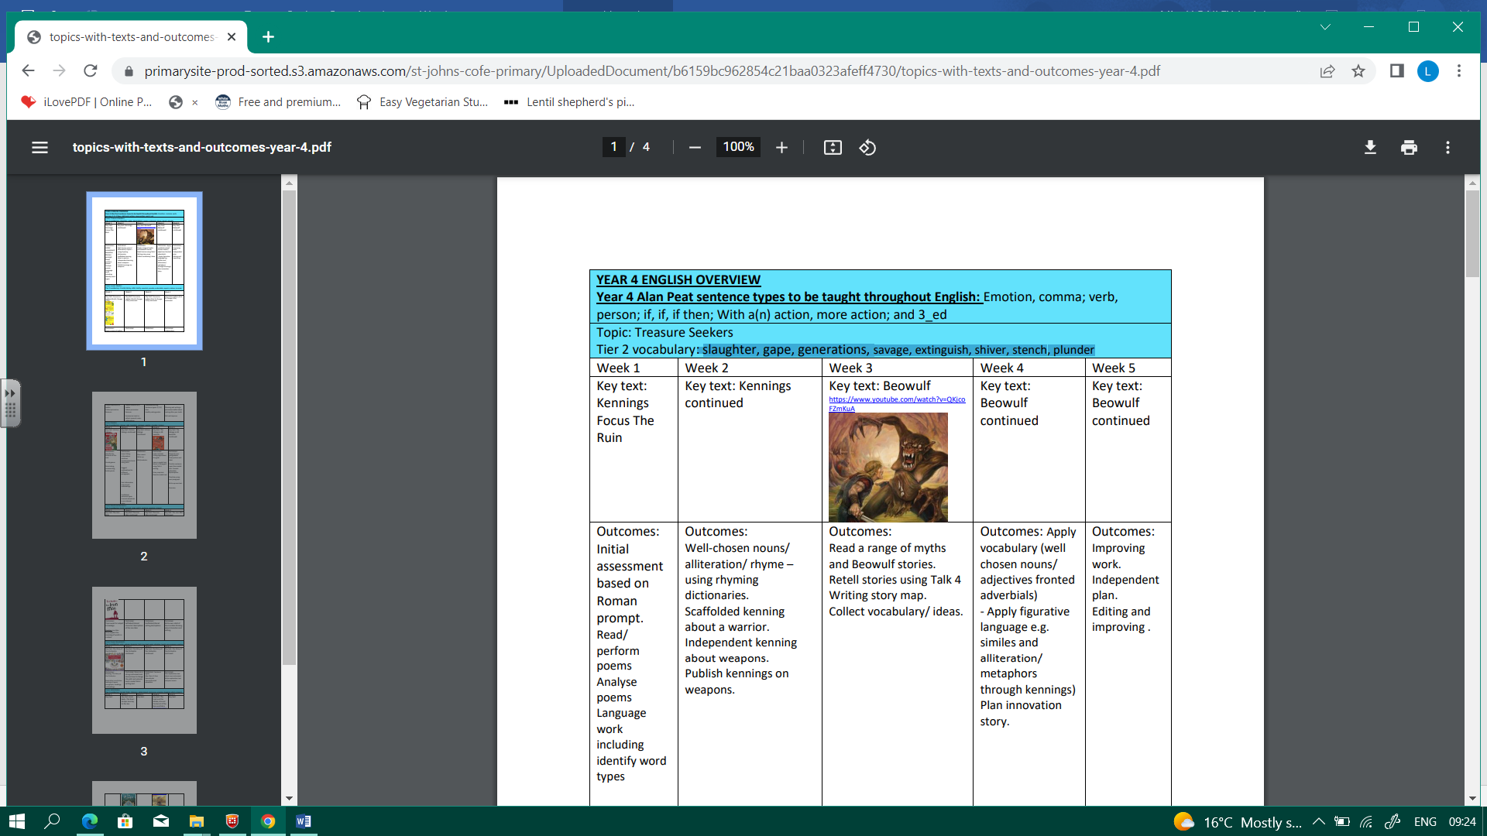
English
We will read a range of myths and Beowulf stories, before retelling part of Beowulf.
slaughter | gape | generations | savage | extinguish | shiver | stench | plunder
Key English Vocabulary (Tier 2 and 3)

Who were the Anglo Saxons? Where did they come from, why and how did they come? When did the Anglo Saxons live? What is the difference between a primary and secondary source? Why is historical interpretation important when thinking about sources?

