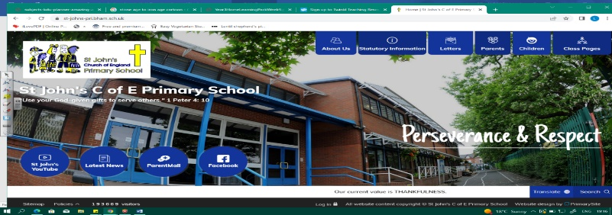
Fabulous Physics and Fitness Freaks
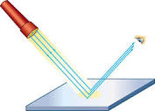
During this unit, we will study physics and biology. We will build on our knowledge and scientific skills from prior learning in Year 3 on light and how it travels. Next, we will look at the human body and deepen our understanding of main body parts and internal organs (our work in Year 4 should help us with this). We should reflect on the role lifestyle on our own wellbeing.
Working Scientifically During this unit, we can improve our skills in:
- planning different types of scientific enquiries to answer questions, including recognising and controlling variables where  necessary. | - taking measurements, using a range of scientific equipment, with increasing accuracy and precision, taking repeat readings when appropriate.  - recording data and results of increasing complexity using scientific diagrams and labels, classification keys, tables, scatter graphs, bar and line graphs.
Can you answer these questions at the end of this unit?
Science Fabulous Physics  - How does light travel?  - How do we see objects that are not sources of light?  - Why do shadows occur? |  | Fitness Freaks  - What are main parts of the circulatory system?  - How does the heart function?  - How can drugs affect our bodies?
reflect | travels | beam | sources | shadow | cast | opaque |  | translucent |  | transparent
transported | circulatory system | nutrients | blood vessels | ventricles | atriums |  | plasm |  | platelets |  | pulse
Key Vocabulary (Tier 3)

English
We will study a piece of visual literacy called The Piano by Aidan Gibbons and will write a narrative for the video. We will also read The Highway Man by Alfred Noyes and will write a short narrative on the poem.
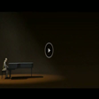  solitary ghastly  limp wistful  taut lifeless | 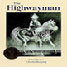  torrent claret brandish  rapier ostler  jest musket
Key English Vocabulary (Tier 2 and 3)

