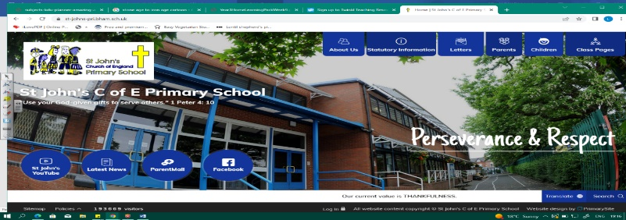
Tomb Raiders
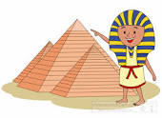
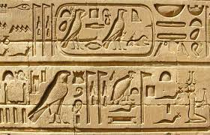
During this unit, we will look at the rise and fall of Ancient Egypt and compare it to other civilisations at the same time in the world. In geography, we look at the importance of the Nile, settlement, maps and early irrigation systems. We will also consider what historians know about life in Ancient Egypt and the impact of this civilisation on our lives.
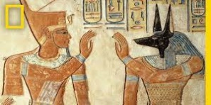
Our learning in Year 3 and Year 5 on ancient civilisations and empires (Greece, Romans, Islamic Golden Age) will help us to deepen our understanding of this dynasty.
Can you answer these questions at the end of this unit?
History  - When did the Ancient Egyptians live?  - What do historians know about life in Ancient Egypt?  - What does it have in common with to life in other ancient civilisations?  - What kind of legacies did this civilization leave us today? | Geography  - Where is Egypt in the world? Which continent?  - Where is the River Nile located? Which countries does it span?  - Describe the climate, biomes and vegetation belts found in Egypt.  - Why did the early Egyptians settle near the River Nile?  - What is irrigation? Why is it important?
dynasty |  | ancient civilisation |  | circa | conquest | legacy | Egyptology
biome | resources | equator | crops | desert | fertile | silt | irrigation
Key Vocabulary (Tier 2 and 3)
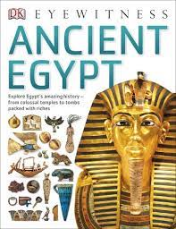
English
We will read information texts on the Egyptians as we compose our own factual, information pieces

