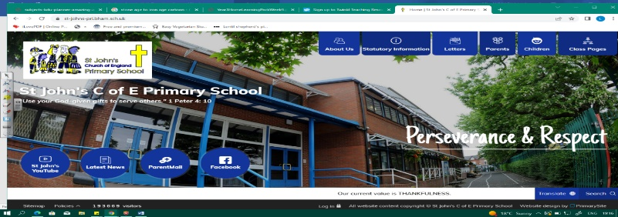
Heroes and Villains
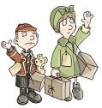
During this unit, we will learn about Hitler’s rise to power in Germany following WWI and events which led to WWII. As well as looking at the geography of Europe at that time, we will also discover what life was like for people and children in wartime Britain. We will study sources, evidence and historical interpretation.
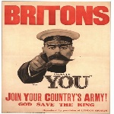
Our previous learning about the Industrial Revolution will help us in understanding changes to life pre- war in Britain. Our work during this unit will allow us to ask questions about prejudice, ideology and how our local area changed after the war.
Can you answer these questions at the end of this unit?
History  - Who were the Nazis and what was their ideology? Over which period did they rise to power?  - Name some key dates and events both leading to and during WW2.  - What was Operation Pied Piper?  - How do historians analyse the causes of WW2?  - Why is it difficult to know what life was really like in Britain during WW2? | Geography  - Where were evacuees sent during WWII? Describe some physical features of these areas. Why were they safer?  - Which were Allied and Axis countries? Show them on a map.  - Which countries does Germany border? Which are land-locked?  - Name some places in UK hit badly by the Luftwaffe and explain why they were hit.
propaganda | political system |  | national socialists |  |  | ideology | Allies Axis |  | Blitz
rationing | evacuation | anti-Semitism |  | treaty | landlocked borders |  |  | natural resources
Key Vocabulary (Tier 3)

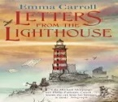
English
We will read Letters from the Lighthouse by Emma Carroll before we write our own letters, documenting life for evacuees. We will also look at a variety of non-fiction texts about WWII.
appetising | Blitz | interior | luscious | loathe | perplexed
Key English Vocabulary (Tier 2 and 3)

