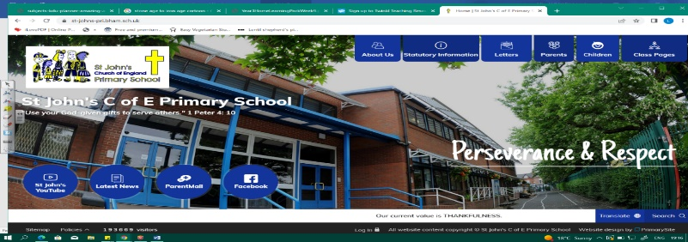
Rise of the Robots
During this unit, we will build on our knowledge from Year 4 work on electrical circuits. We will form questions about how increasing the voltage in a circuit might affect the components. We will then design an experiment to test this and build a simple circuit. We must use our skills from KS2 to create a fair test. The skills we acquire in this unit will help us in our next DT project, as we use electrical circuits to build a fairground ride.
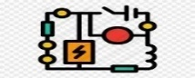
Working Scientifically
During this unit, we can improve our skills in:
- planning different types of scientific enquiries to answer questions, including recognising and controlling variables where necessary.  - recording data and results of increasing complexity. | - using test results to make predictions to set up further comparative and fair tests  - reporting and presenting findings from enquiries, including conclusions, causal relationships and explanations of and a degree of trust in results.
Can you answer these questions at the end of this unit?
Science  - If I went to America, where the voltages in plugs are lower, what would happen to my hair dryer?  - What happens when you increase the volts within a circuit with a bulb?  - What is the symbol for a motor? |  | - If I want to know whether the motor gets faster if I add more batteries, which variables should stay the same and which should change?  - How could you design a burglar alarm?  - What precautions should you take when working with electricity?
voltage | circuit | electrons | cell | motor | buzzer | bulb
battery | components | precaution | symbols | circuit diagrams
Key Vocabulary (Tier 3)

English We will begin by looking at a piece of visual literacy called Origins: A Lone Robot. Then we will read extracts from The Snow Walker’s Son by Catherine Fisher. Finally, scientific explanation texts will help us as we write explanations for our circuits.
canopy | horizon | amber | glowing | harmony | symphony
birdsong | haven | tranquil | desolate | looming | isolated
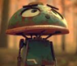
Key English Vocabulary (Tier 2 and 3)

