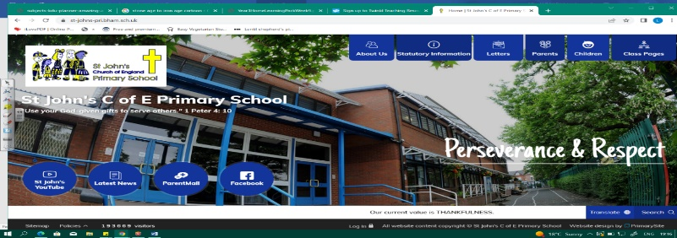
Talking ‘Bout a Revolution
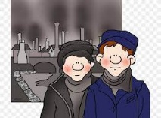
During this unit, we will discover when and why the Industrial Revolution in Britain took place. We will explore changes to life as a result of population movement, growth and the development of industry. We will become skilled geographers as we look at settlement, maps and migration. We will also study evidence, historical interpretation, cause and change.

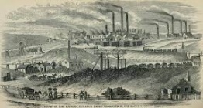
Our learning in Year 2 about the Cadbury family in Bournville during this period will help us in understanding changes to our local area. Our discoveries will also help us understand more about life in pre-war Britain, as we study WWII later in the year.
Can you answer these questions at the end of this unit?
History  - When did the Industrial Revolution take place in Britain? What happened and why?  - What were the changes to life that the Industrial Revolution brought?  - Why do different versions of the past exist? What do historians call this?  - Do historians think the Industrial Revolution was a good thing for Britain? What was the legacy it left? | Geography  - What do terms urban and rural refer to?  - How has Birmingham changed over time pre and post-Industrial Revolution?  - Describe the population growth around Birmingham during the Industrial Revolution? Can you show it on a map?
industry | revolution | progress | migration | trend
child labour | agriculture | population density | land use patterns | rural v  urbanisation | human/physical features
Key Vocabulary (Tier 3)

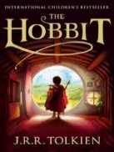
English
We will read The Hobbit by J.R.R Tolkien and create our own descriptions of Hobbit Hole. We will then study Street Child by Berlie Doherty before looking at Benjamin Zephaniah’s poetry. This unit celebrates authors from Birmingham and explores themes of identity and culture.
cottage | industries | machinery | steam engines | workforce | factories
Key English Vocabulary (Tier 2 and 3)

