
The Empire Strikes Back
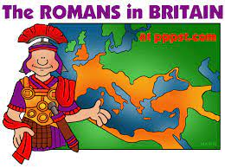
During this unit, we will learn about the Roman Empire, its reach across Europe and the Roman invasion and occupation of Britain. We will research life in Roman Britain and legacies they left, as well as study sources. Our learning in this year about the Iron Age Celts and the Ancient Greeks will help us to understand when this period took place and how these peoples are connected. In geography, we will look at some of Italy’s human and physical features, and compare Roman settlements to Iron Age hillforts.
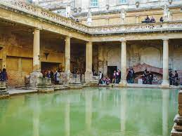
The knowledge we gain in this unit will help us at the beginning of Year 4 to understand how the Anglo Saxons and Vikings fit into the story of Britain.
Can you answer these questions at the end of this unit?
History  - Who was in Britain when the Romans invaded? When, why and how did they invade?  - What was life like in Roman Britain? How do historians know? Do all historians agree with each other about what sources tell us?  - What were the legacies of Roman occupation in Britain?  - How have historians played a part in how we see Boudicca? | Geography  - Where in the world is Italy? In which continent is Italy? What is the capital city?  - Describe some physical features of Italy?  - Describe some human features of Italy.  - What kind of settlements did Romans build? Compare then to Iron Age Hillforts.
empire | military | invasion | occupation | resistance | gladiator |  | artefacts
mosaic | peninsula | biomes | landmarks | human and physical |  | climate |  | population
Key Vocabulary (Tier 3)
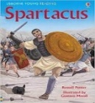
English
We will read Usborne’s Spartacus and think about the legend of the real Spartacus. We will also read a range of playscripts and then turn chapter 2 of Spartacus into a playscript!
sweltering | desert | discipline | rebels | plunder
Key English Vocabulary (Tier 2 and 3)

