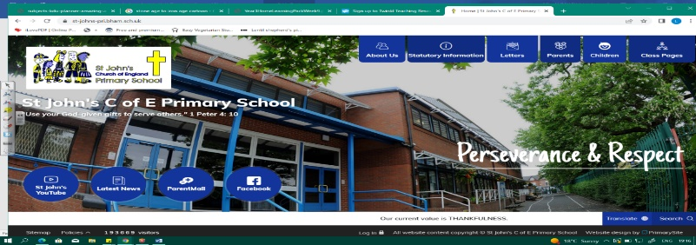
Brilliant Botanists
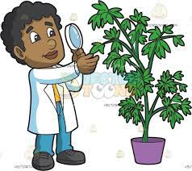
During this unit, we will learn all about botany, as well as light and shadows. We will build on our knowledge of how plants grow and what they need from Year 2 and study the functions of different parts of flowering plants. We will plan an investigation about how water is transported within plants, then explore the life cycles of flowering plants.
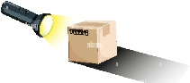
To end the unit, we will consider sources of light, sun safety, shadows and carry out experiments on changing shadows.
Working Scientifically
During this unit, we can improve our skills in:
- making systematic and careful observations and, where appropriate, taking accurate measurements using standard units, using a range of equipment, including thermometers and data loggers.
- setting up simple practical enquiries, comparative and fair tests, using results to draw simple conclusions, make predictions for new values, suggest improvements and raise further questions.
- identifying differences, similarities or changes related to simple scientific ideas and processes.
Can you answer these questions at the end of this unit?
Science  - In the world, there are droughts. What happens to the plants in these areas?  - Why does a plant need roots? | - How do seeds travel (disperse)?  - What does pollination mean?  - How does the sun affect our shadows throughout the day?  - Name 3 types of light source.
growth | nutrients | transported | life cycle | pollination | seed dispersal | seed formation
pollen | shadows | opaque | light source | reflection | transparent | translucent
Key Vocabulary (Tier 3)

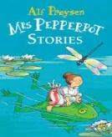
English
We will read Mrs Pepperpot and the Magic Wood by Alf Prøysen, focus on setting description and then write our own stories in the style of Mrs Pepperpot, complete with plot and characters.
feathery | winding | inconvenient | gingerly
Key English Vocabulary (Tier 2 and 3)

