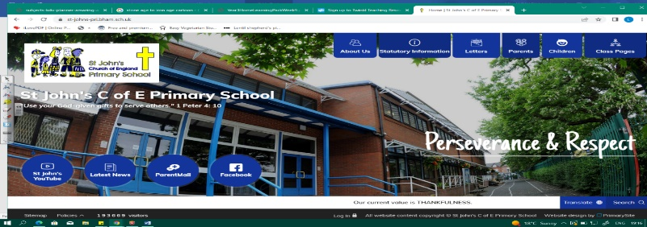
You Are What You Eat
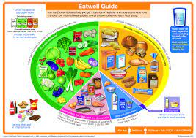
During this unit, we will build on our knowledge about parts of our bodies from KS1 by learning the functions of different muscles and bones. We will discover the role of nutrients, what a balanced diet looks like and how important it is for us. We will also classify different animals by their bone structures and consider their basic needs for survival.
Our learning in this unit will prepare us to study the human body in more depth in Year 4.
Working Scientifically
During this unit, we can improve our skills in:
- gathering, recording, classifying and presenting data in a variety of ways to help in answering questions.
- identifying differences, similarities or changes related to simple scientific ideas and processes.
Can you answer these questions at the end of this unit?
Science  - How are we similar to a bear and different to a snake?  - Which muscles can you move and which muscles move without you thinking about them?  - How do humans get nutrients? | 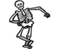  - Can you name 3 different examples of carbohydrates?  - What food should we eat as part of a balanced diet?  - Why do humans have a skull? What is it protecting?
nutrients | carbohydrates |  | protein | dairy |  | sugar | fat |  | fruit | vegetables | skeleton
muscles | support | protection |  | movement | spine |  |  | rib cage |  | vertebrates |  | invertebrates
Key Vocabulary (Tier 3)

English
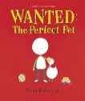
We will study The Sound Collector by Roger McGough and the Taste Taker by Josie Whitehead, before writing our own food poems! We will also read non-fiction persuasive texts, writing our own leaflet to persuade Henry (from Wanted: The Perfect Pet by Fiona Roberton) to buy a pet.
system | develop | sources | provides | variety | sternly | common | disguise | discovery
Key English Vocabulary (Tier 2 and 3)

