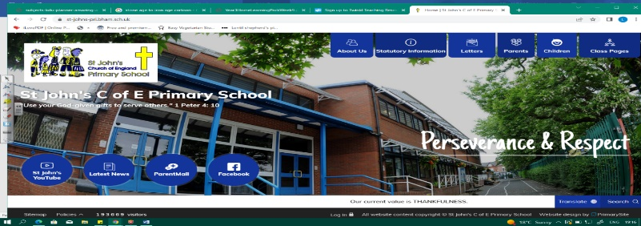
Gods and Heroes
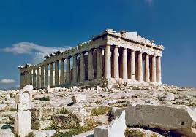
During this unit, we will discover who the Ancient Greeks were, when they lived and how they influence our lives today. We will look at sources carefully to research daily life, democracy and philosophy. Our learning about the Celts in Britain around the same time will help us to compare how different people lived during similar periods. We will also examine ancient and modern maps of Greece and explore human and physical features of Greece today.
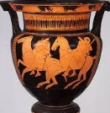
Our learning in this unit will be important as we explore the Roman Empire and the Romans in Britain later in Year 3.
Can you answer these questions at the end of this unit?
History  - What is an ancient civilisation? What other ancient civilisations can you name? Where and when did Ancient Greece exist?  - What legacy have the Ancient Greeks left?  - How was life in Ancient Greece different/same as life in Iron Age Britain?  - How can historians understand the same event differently? Can you give an example? | Geography  - How is modern Greece different to Ancient Greece?  - Where in the world is Greece? In which continent is Greece? What is the capital city?  - Describe some physical features of Greece.  - Describe some human features of Greece Why do people want to visit?
democracy | philosophy |  | trading |  | slavery |  | legacy | ancient civilisation |  | sources
peninsula |  | climate |  | equator |  | landmarks |  | population | Mediterranean
Key Vocabulary (Tier 3)

English
We will read a range of Greek Myths and focus on Theseus and the Minotaur, as we retell it. To end the unit, we will look at Eric Finney’s poem Thor and write a poem about a Greek god/goddess in the same style.
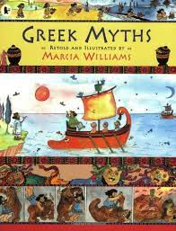  hoisted victims  prevent cruelty | 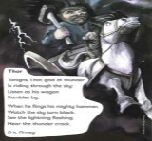  wagon rumbles flings  mighty prisoners  escape rose
Key English Vocabulary (Tier 2 and 3)

