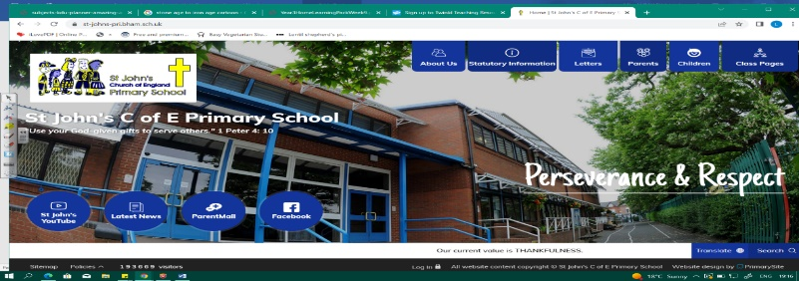
Genius Geologists
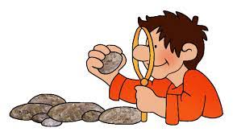
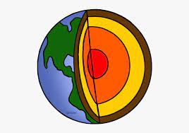
During this unit, we will study geology and understand how science, geography and history are all involved! We will begin by looking at different types of rock and soil, then explore volcanoes, earthquakes and tsunamis. In history, we will learn about Mary Anning’s fossils and examine evidence of Pompeii and how scientists, historians and archaeologists know about what happened there.
Working Scientifically During this unit, we can improve our skills in:
- identifying differences, similarities or changes related to simple scientific ideas and processes
- using straightforward scientific evidence to answer questions or to support findings
Can you answer these questions at the end of this unit?
Science  - Why might people live in volcanic areas? What are the benefits?  - What is rock made from?  - Can you name 3 different types of rock? How are they different?  - How is a fossil formed? | Geography  - Where are the highest ranges in the UK?  - How is a volcano formed, what happens when it erupts?  - Where do the most powerful earthquakes in the world tend to happen? Why? What happens when an earthquake takes place? | History  - What is the difference between and primary and secondary source?  - When did Mary Anning live and how do historians view her?  - Where, when and how did Pompeii happen? Do all historians agree about what the sources tell us?
physical processes | fossils | soils | metamorphic |  | sedimentary |  | igneous | tectonic plates
plate boundaries | tremors | epicentre | Pompeii | reliable |  | primary secondary sources
Key Vocabulary (Tier 3)

English
We will begin with Stone Girl Bone Girl by Lawrence Anholt and write diary extracts as Mary Anning. We will then explore Escape from Pompeii by Christina Balit, before writing our own volcano eruption description.
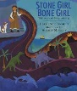  gather tremendous curiosity furious jagged | 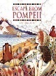  drift beneath loom  quiver beyond
Key English Vocabulary (Tier 2 and 3)

