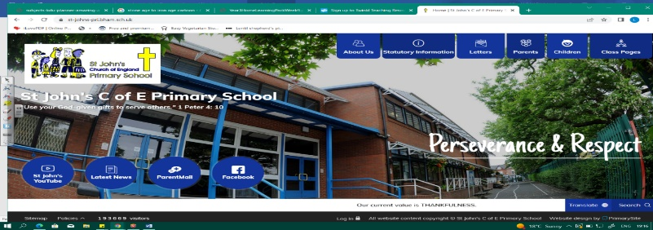
Feel the Force
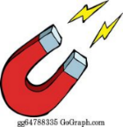
During this unit, we will discover how forces work! Our Year 1 and 2 learning about magnets and materials means we will soon become experts! We will ask questions about a variety of surfaces and how objects move differently. By designing our own experiments using different materials, we can test out hypothesis. We should investigate magnets, poles, and how they can attract or repel each.
Our learning about forces will help us in Year 5 when we learn about forces and space.
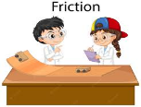
Working Scientifically
During this unit, we can improve our skills in:
- asking relevant questions and using different types of scientific enquiries to answer them  - setting up simple practical enquiries, comparative and fair tests. | - recording findings using simple scientific language, drawings, labelled diagrams, keys, bar charts, and tables  - reporting on findings from enquiries.
Can you answer these questions at the end of this unit?
Science  - How could I test whether something is magnetic?  - If I were testing how fast a car goes, using a ramp and materials, what would I need to change and what would I need to keep the same? | - Will a car move faster or slower over a bumpier surface than a smooth surface? Why?  - Name 2 materials that are magnetic?  - If I put two magnets together, what would happen?
push pull | surface | force | properties | repel attract
hypothesis | fair test | friction | magnetic force | magnetic poles
Key Vocabulary (Tier 3)
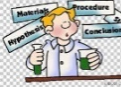
English
We will study non-fiction scientific reports, as we then write one of our own.
report | equipment | method | variable | texture
motion | direction | travelled | hypothesis | conclusion
Key English Vocabulary (Tier 2 and 3)

