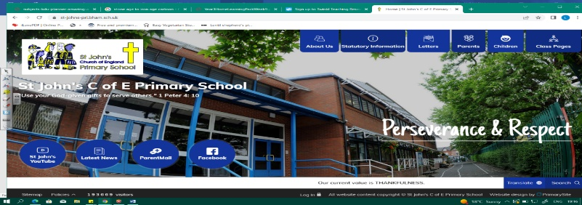
Amazing Archaeologists! Stone Age to Iron Age
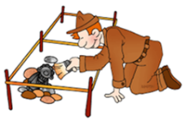
During this unit, we will discover who the Stone Age, Bronze Age and Iron Age people were and when they lived. Our learning in Year 2 about Aboriginal people in Australasia will help us to understand when the Stone Age happened. We will also learn more about sources, historians, how we know about the past, change and continuity.
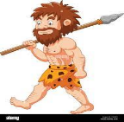
We will explore different tools, metals, settlements, the ways people lived and why they changed. Our discoveries about Iron Age people will help us when we study Romans at the end of the year.
Can you answer these questions at the end of this unit?
History  - What’s the difference between prehistoric and historic eras?  - What does BC and AD mean? Why is it important?  - What is the role of an archaeologist and historian?  - Describe a source of evidence from period? How do historians use evidence?  - How did life change for people across the 3 ages (materials, settlement and farming)? | Geography  - Where are the names of some famous prehistoric sites in the UK? Can you find them on a map?  - Why did the Celts build hillforts? How did they use the land? How was this different to Bronze and Stone Age settlements?
Palaeolithic Mesolithic  Neolithic |  | age | BC AD | prehistory | archaeologist | artefact | nomad
hunter gatherer | Celts | hillfort roundhouses |  |  | tribal kingdoms | settlement | community
Key Vocabulary (Tier 3)

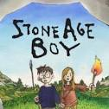
English
We will read the Stone Age Boy by Satoshi Kitamura, create our own Stone Age setting and write a description of it. We will also study non-fiction texts and design an information poster about the Iron Age.
wandering | stumble | munch | relief | flickering
Key English Vocabulary (Tier 2 and 3)

