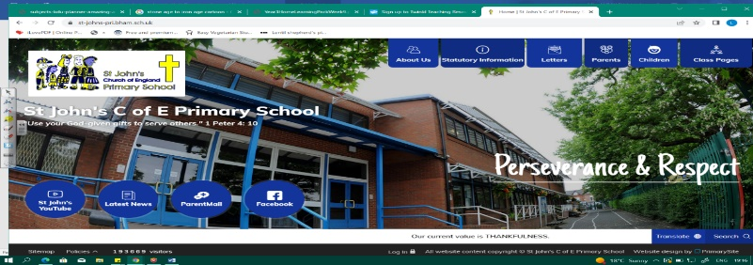
Busy Biologists
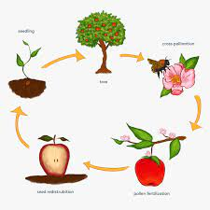
During this unit, we will learn about the study of biology and examine humans, plants and animals carefully. We will learn about changes as humans develop to old age, using our knowledge of growth from KS1. We will then look at mammals, amphibians, insects and birds and their life cycles. Our learning in Year 3 about plant life cycles will give us a starting point.
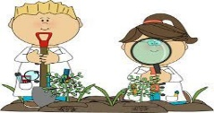
Working Scientifically
During this unit, we can improve our skills in:
- identifying scientific evidence that has been used to support or refute ideas or arguments.
- using science experiences to explore ideas and raise different kinds of questions.
- recognising which secondary sources will be most useful to research ideas and begin to separate opinion from fact.
Can you answer these questions at the end of this unit?
Science  - Why are bees so important?  - What are the differences between babies, toddlers and teenagers? | - How do plants reproduce?  - What are the reproductive organs of a plant?  - How can you tell whether a secondary source is useful?  - How is the life cycle of a mammal and reptile different?
adolescent | mammal | amphibian | reproduction | naturalist
develop | gestation | embryo | foetus | puberty
Key Vocabulary (Tier 3)

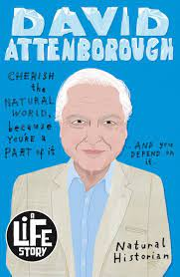
English
We will read examples of biographies of naturalists, conservationists, wildlife experts like Jane Goodall and David Attenborough. We will finish our unit by studying the performance poetry of Brian Moses I’m Walking with my Iguana.
ground-breaking | fascinating | impact | discoveries |  | companion |  | revolutionise
adventurous | determined | dedicated |  | leash |  | grim | observing
Key English Vocabulary
(Tier 2 and 3)

