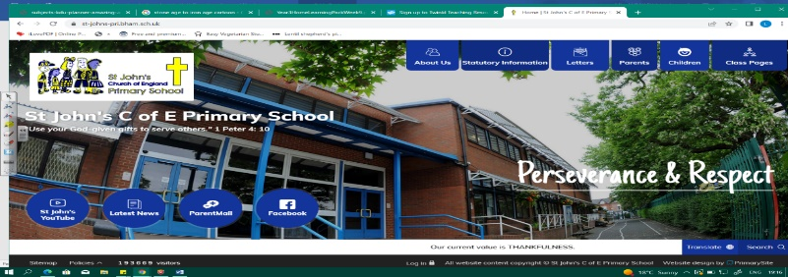
Star Trek
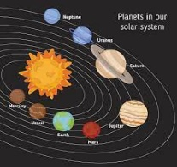
During this unit, we will discover more about forces and friction. Our learning from Year 3 (Feel the Force) will help us to see how forces affect our lives. We will plan testing that will tell us about the effect of gravity, air resistance, water resistance and friction. Our exploration of the solar system will give us knowledge about planets, the movement of the moon and Earth’s rotation.
Working Scientifically During this unit, we can improve our skills in:
- planning different types of scientific enquiries to answer questions, including recognising and controlling variables where necessary.  - taking measurements, using a range of scientific equipment, with increasing accuracy and precision, taking repeat readings when appropriate | - reporting and presenting findings from enquiries, including conclusions, causal relationships and explanations of and a degree of trust in results, in oral and written forms such as displays and other presentations.  - identifying scientific evidence that has been used to support or refute ideas or arguments.
Can you answer these questions at the end of this unit?
Science
- How long does the Moon take to orbit the Earth? How long does the Earth take to orbit the Sun?
- What shape are the Moon, Earth and Sun?
- What is gravity measured in?
- How could you make a car go faster?
- Can you give an example where gears and pulley are used in day to day life?
gravity | air resistance | water resistance | friction | mechanisms |  | levers | pulleys | gears
Newtons | relative | Solar system | spherical bodies |  | rotation |  | orbit
Key Vocabulary (Tier 3)

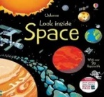
English
We will read a range of non-fiction books about space and the solar system, as we then write our own explanation texts. The unit will end with a study of Pie Corbett’s Space Poems.
glitch | formed | accelerate | intergalactic | interstellar | launching
transmitting | futuristic | conventional | potential | nestled | communication
Key English Vocabulary
(Tier 2 and 3)

