
Earth Explorers
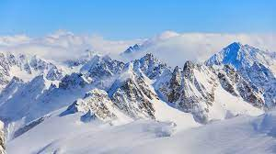
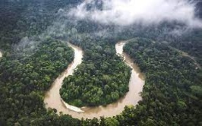
During this unit, we will discover more about mountains and their regions in the world. We will also learn about rainforests, their location in the world, climate and physical features. We will become more skilled in using atlases, globes and world maps to learn more about continents, the Equator, the Tropics of Cancer and Capricorn and why they are important. We carry out of study of the Amazon Rainforest, considering the effect of deforestation on communities and on the world.
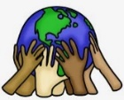
Our learning about rainforests in Year 1 (Really Wild Safari) and mountains in Year 3 (Genius Geologists) will help as we develop deeper understanding.
Can you answer these questions at the end of this unit?
Geography
- Name and describe some different mountain ranges in the UK and the world (show on maps).
- What is the height of the tallest mountain in the world?
- What is a biome?
- Name and describe the different layers of a rainforest. Where are the Brazilian rainforests in relation to the equator/Tropics of Cancer and Capricorn and why is this important?
- What is deforestation and why is it happening?
U shaped valley | glaciers | biome | climate | equator |  | Tropics of Cancer/Capricorn
forest floor | understory | canopy | emergent |  | deforestation |  | physical processes
Key Vocabulary (Tier 3)


English
We will read Anthony Horowitz’s Alex Rider Point Blanc and write our own descriptions, then focus on the Amazon Rainforest in the Great Kapok Tree by Lynne Cherry.
concealed | occurred | eerie | impaled | perilous | deserted
drained | relieved | relief | glistened | luminous
Key English Vocabulary
(Tier 2 and 3)

