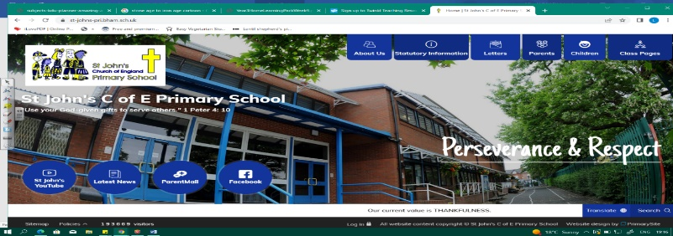
The Islamic Golden Age
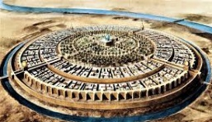
During this unit, we will discover the significance of the Islamic Golden Age, its achievements and influence on our lives today. In history, we will examine when it happened and what was happening in Europe at the same time. This is where our learning from Year 3 and 4 about other civilisations of the same period will be helpful!
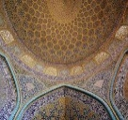
We will study evidence and how we know about this amazing time in history. As geographers, we will develop our locational knowledge of the Middle East and its countries. We must understand why the Silk Road was important and learn about why Baghdad was chosen to be a pioneering settlement.
Can you answer these questions at the end of this unit?
History  - When was the Islamic Golden Age? What was happening in other parts of the world at the same time?  - What happened in Bagdad and how did it mark the end of the Islamic Golden Era?  - Name and describe primary and secondary sources and what they may tell historians about life during this period.  - What were some of the main achievements of the Islamic Golden Age? | 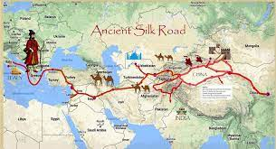  Geography  - Where is the Middle East? Name some countries and their continents.  - What is the Silk Road and why was it essential?  - Why was Baghdad a pioneering type of settlement? Describe how it was built. Describe some physical features of Bagdad.
dynasty | siege | Mongol Empire |  | scholar |  | caliphate |  | House of wisdom
advancements | trade route |  | Middle East |  | Silk road |  | land use | import export
Key Vocabulary (Tier 3)

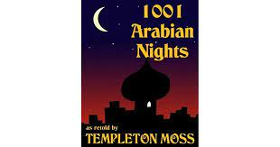
English
We will read a collection of Middle Eastern folk tales 1001 Arabian Nights, explore descriptive vocabulary before retelling the story of Aladdin and Ali Baba.
dazzles | heaped | conjure | scamp |  | merchant | merrily
sumptuous | gems | fortune |  | shimmering
Key English Vocabulary (Tier 2 and 3)

