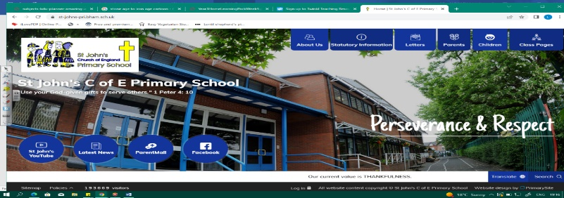
Materials Matter
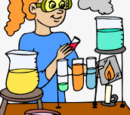
During this unit, we will investigate properties of different materials, look at solids, liquids and gases, and learn about reversible and irreversible changes. We will plan fair and comparative tests to explore solutions and changes of state. Our learning from Year 2 (Let’s Go Engineering) on the properties of different materials will help us.
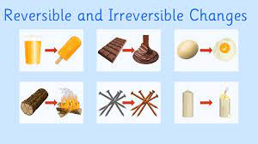
Working Scientifically
During this unit, we can improve our skills in:
- planning different types of scientific enquiries to answer questions, including recognising and controlling variables where necessary.  - recording data and results of increasing complexity. | - using test results to make predictions to set up further comparative and fair tests.  - reporting and presenting findings from enquiries, including conclusions, causal relationships and explanations of and a degree of trust in results.
Can you answer these questions at the end of this unit?
Science
- Do you think climate change is a reversible or irreversible change?
- How could you separate a solution? Can you name one reversible and one irreversible changes?
- Can you give an example of a mixture and an example of a solution?
- How could you separate a mixture? What is the difference between a mixture and a solution?
properties | solubility | transparency | conductivity | electrical | thermal |  | magnetic |  | solution
mixture | dissolve | filtering | sieving | evaporating |  | reversible |  | irreversible
Key Vocabulary (Tier 3)

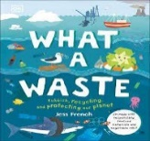
English
We will read a range of non-fiction texts about scientific processes, plastic and recycling. We will write scientific explanations and learn about features of persuasive texts before writing our own.
impermeable | permeable | translucent | porous | durable
responsibility | rigid | flexible | opaque | transparent
additionally | despite | unfortunately | surprisingly | however
Key English Vocabulary
(Tier 2 and 3)

