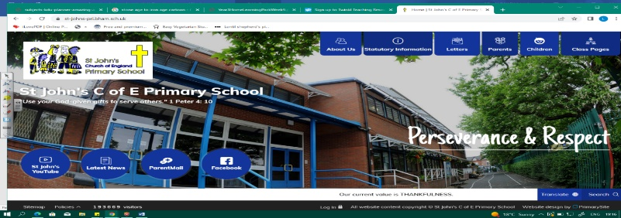
All the World’s A Stage
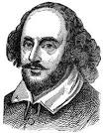
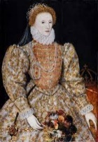
During this unit, we will discover who William Shakespeare was, when and where he lived. We will develop as geographers as we look at maps, study the river Avon and consider how Stratford Upon Avon has changed since the 1600s. In history, we will consider how historians build a picture of the past and why Shakespeare is so significant in the world. Our learning in about the Tudors in Year 1 (Whizz, Bang Pop) and Year 2 (Fire Fighters) will help us in deepening our understanding of the period.
Can you answer these questions at the end of this unit?
History  - Who were the Tudors? In which century did the Tudors live?  - How did Elizabethans enjoy themselves? How do we know?  - Is Shakespeare a significant figure in the world today? What do historians think?  - Name evidence that tells historians what Elizabeth I was like. | Geography  - Where is Stratford Upon Avon? Show on a UK map.  - What does a topographical map show us?  - Can you describe some topographical features (physical features) around Stratford area?  - How has land-use changed over time in Stratford? Why?  - Describe parts of the river Avon. Why was it important to the Tudors?
reign | monarchy | Tudor | Elizabethan | James 1 |  | Jacobean era
historical interpretation | physical human features | rural urban | population | estuary | mouth  (river) | source (river) | bank  (river)
Key Vocabulary (Tier 3)

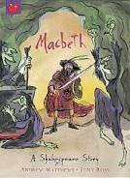
English
We will read Shakespeare’s MacBeth and write our own setting description, before studying Romeo and Juliet.
withered | flickered | ghastly | sweltered | agony
sinister | devastated | malicious | dismayed | agony
Key English Vocabulary (Tier 2 and 3)

