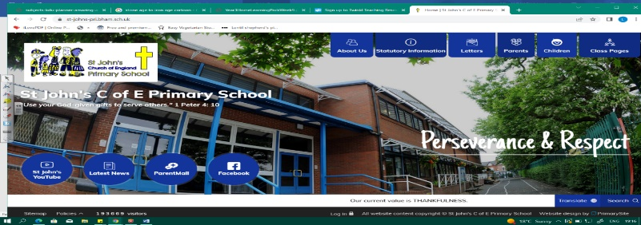
Fight for Your Rights!
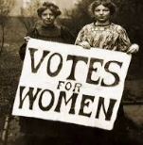
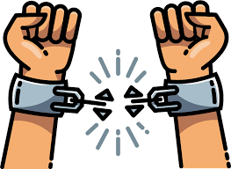
During this unit, we will learn about people who have helped to change the world. We will begin by looking at the Magna Carta and why it is important, then explore themes of slavery, women’s suffrage, civil rights and equality of access to education. Our learning in Year 3 about slavery in Ancient Greece and the Roman Empire will help us in our understanding of the Transatlantic Slave Trade.
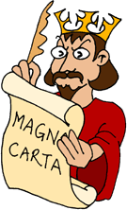
We must examine evidence and consider how historians use it to interpret the past. In geography, we will study maps, continents, countries, Transatlantic routes and economic and natural resources. We must think about how we can make a difference in the world.
Can you answer these questions at the end of this unit?
History  - What is the Magna Carta and why is it important to historians?  - What is a legend? Why do historians argue about Robin Hood?  - What were the social and economic factors involved in the Slave Trade?  - Describe one significant figure and say how his/her life affects us today. | 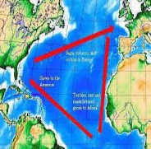  Geography  - What do the terms trade and transportation mean?  - Which countries and continents were involved in the Transatlantic Slave Trade?  - What is meant by a country’s resources (natural and economic)?
decade century | Magna Carta |  | legend | abolition | civil rights | legend |  | suffrage
desegregation | enslaved | trade routes |  | resources (natural and economic) |  |  | Transatlantic
Key Vocabulary
(Tier 3)
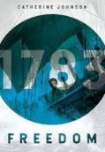
English
We will read different versions of the legend of Robin Hood, then write character and setting descriptions. We will use non-fiction texts to create our own information texts about the Suffragists. Our unit will end with poetry and responding to Maya Angelou’s The Caged Bird.
outlaw | cunning | devised | brutal | mischief | enslaved
captive | branded | shackled | plantation | human rights | violated
Key English Vocabulary
(Tier 2 and 3)

