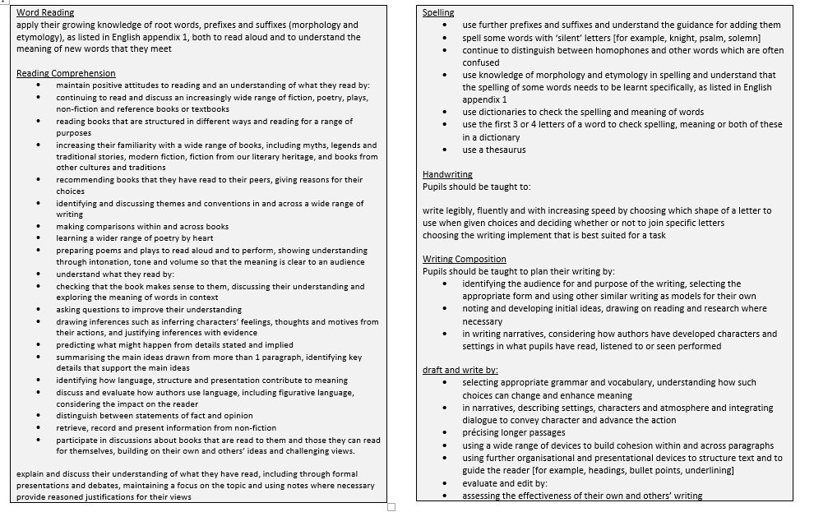
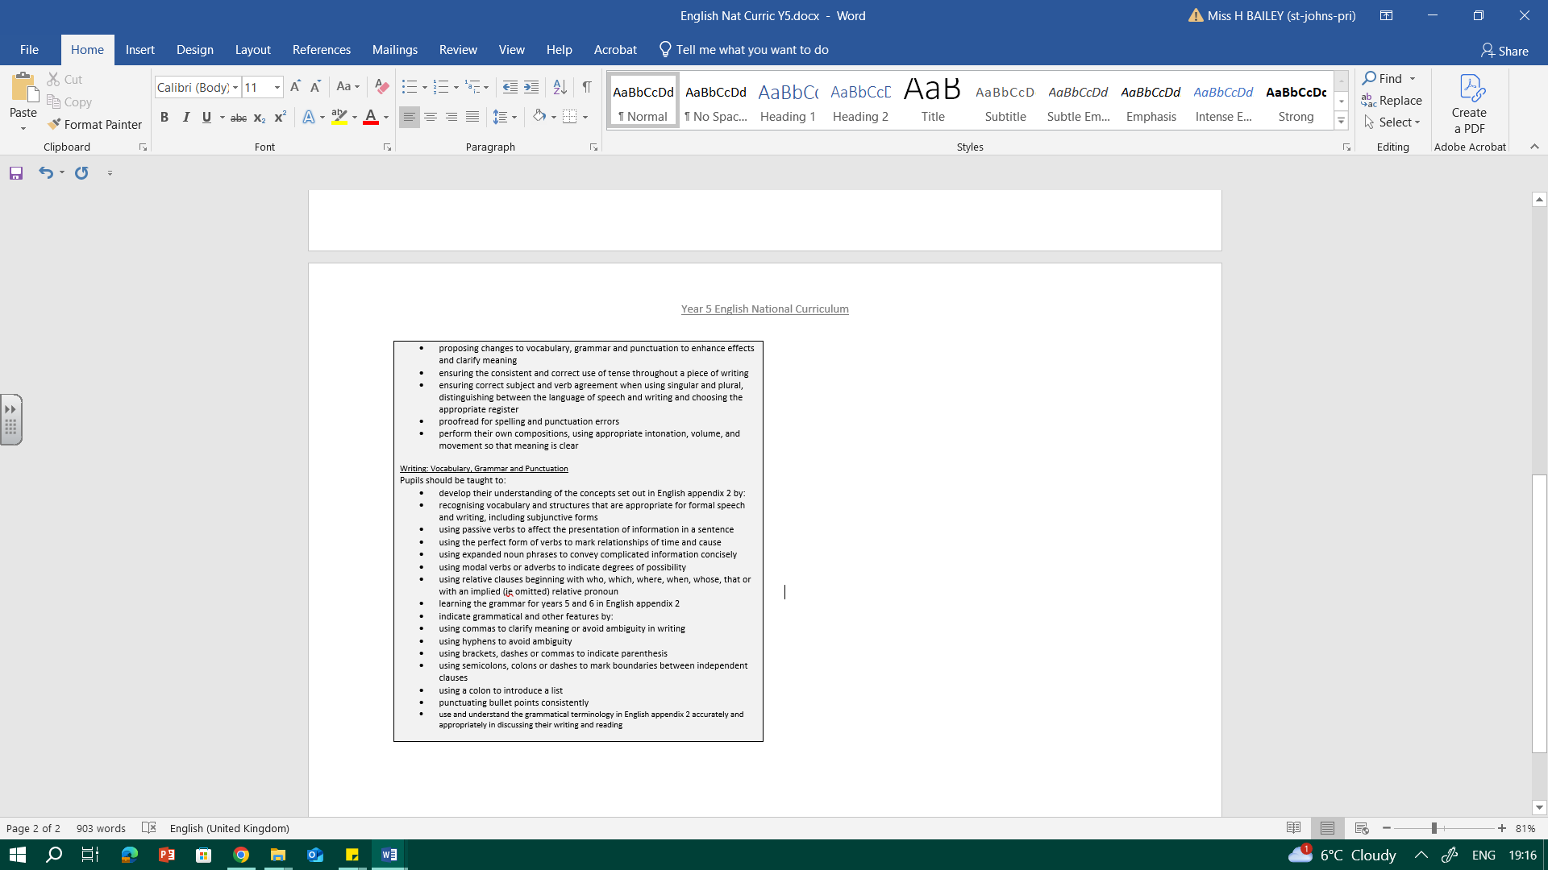

YEAR 5 ENGLISH OVERVIEW
Alan Peat sentence types to be taught in English:
Noun, which/who/where; 2 pairs sentences; 3 bad – (dash) question?; Name – adjective pair – sentences
Topic: Freedom Fighters
Tier 2 vocabulary: outlaw, cunning, devised, brutal, mischief
Enslaved, captive, branded, shackled, plantation, human rights, violated
Physical Oracy:  Deliberately varies tone of voice in order to convey meaning e.g. speaking authoritatively during an expert talk, or speaking with pathos when telling a sad part of a story. |  |  |  | Linguistic Oracy:  Use an increasingly sophisticated range of sentence stems with fluency and accuracy (Maths Ark talk tasks)
Cognitive Oracy:  Draw upon knowledge of the world to support their own point of view and explore different perspectives |  |  |  | Social & Emotional Oracy:  Listen for extended periods of time including notetaking, drawing visual
Week 1 | Week 2 |  | Week 3 |  | Week 4 |  | Week 5
Key text:  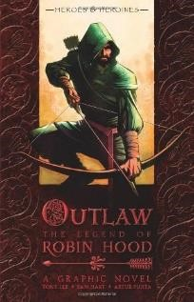  Robin Hood and the Silver  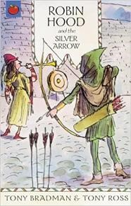  Arrow | 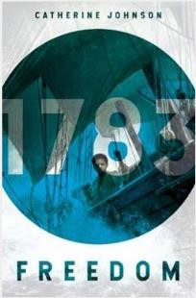  Key text:  Freedom |  | Key text:  Freedom  Selection of Little People/Big Dreams books |  | Key text:  Information texts and non-chronological reports |  | Key text:  Maya Angelou  “Caged Bird”  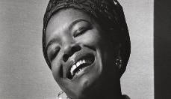
Robin Hood  Outcomes: Topic sessions looking at sources of information about Robin Hood to provide back ground knowledge. Children to read a range of different versions of Robin Hood to retell orally.  Children create character descriptions using consolidated sentence types. | Outcomes: Read different versions of Robin Hood. Explore the idea of myths/legends and oral retelling tradition. Children develop descriptive techniques to create a setting description of Sherwood Forest, retelling part of the story of Robin Hood, using Alan Peat sentences types. |  |  |  | Suffragettes  Outcomes: Create an information poster exploring the Suffragist movement, focusing on a key figure. Including Alan Peat sentence types  -Using clauses at front, middle or end of sentences- combining clauses.  - Compound sentences with coordinating conjunctions  - Complex sentences with subordinating conjunctions  - Complex sentences with multiple clauses. |  | Civil Rights  Outcomes:  Poetry responses to the civil rights movement.
Topic: Shakespeare
Tier 2 vocabulary: malicious, sinister, withered, flickered, ghastly, sweltered, agony, dismayed, devastated.
Week 1 |  | Week 2 |  |  |  | Week 3 and 4
Key text: The Shakespeare Collection books.  Hook with Romeo and Juliet  Focus on Macbeth  Macbeth – key text |  | Key text: Macbeth |  |  |  | Key text: Romeo and Juliet - orchard books

 |  | 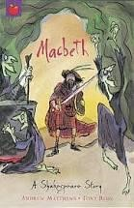
Week 1 – Macbeth. Read story (short version) gather vocabulary.  Use the witches spell as a stimulus for writing own. |  | Setting Description:  Witches on the heath: 3 bad – question sentence 2 pair sentence  Cohesion  Shared write setting description |  |  | Week 3 and 4  Romeo and Juliet  Week 3: Compare prologue with Baz  Lerman version  Look at setting and gather vocab. Chn independent write setting description  Week 4: Speech focus: add speech to extend setting description.
Topic: Materials Matter
Tier 2 Vocabulary: Additionally, However, despite, unfortunately, surprisingly, responsibility
Tier 3 vocabulary: Porous, durable, rigid, flexible, opaque, transparent, translucent, impermeable, permeable, solids, liquids and gases, particles.
Key text:  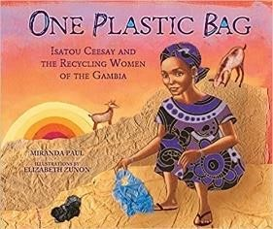  Hook text: One Plastic Bag  Non-fiction text: What a  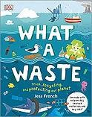  WasteRead a range of nonfiction/information texts about: scientific processes plastic/ recycling | Key text: |  | Key text: | Key text:
Persuasive texts:
Identify features of a persuasive text: conjunctions, scientific vocab, modal verbs, addressing the reader, formal tone, emotive language. Build up a piece of persuasive writing over 2 weeks, persuading people to either recycle or keep plastic out of the ocean.

Children learn about different scientific processes – solute/solution investigation, rusty nail investigation etc. Children use the skills they learnt in CCs to write up their science investigations using high-quality English content. Have re-cap lesson on features of scientific explanations – look at lots of books from the school library, watch scientific (“explanation”) videos from cbeebies – look at transcripts of what the presenters say! This is essentially a science investigation, but presented orally. Make imovies! Or if time, children could write up their science investigations to be presented as a science show on cbeebies.

Outcomes:  Topic focus- Labelled scientific diagrams with short explanations about mixtures,  filtration, solutions,  Read and research the material of plastic. | Outcomes: Oral practise at using the scientific vocabulary correctly when discussing science investigations and practical observations.  Read and research plastic pollution. |  |  | Outcomes: Explore the features of persuasive texts. Read persuasive letters Children identify the problem and what the writer is trying to convince somebody to do/believe/etc  Research a single use plastic problem in the local area. |  |  |  | Outcomes: persuasive writing about not polluting the sea.
Topic: The Islamic Golden A | ge
Tier 2 vocabulary: shimmeri | ng, dazzled, heaped, conjure, scamp, merchant, merrily, sumptuous, gems, fortune
Physical Oracy:  Project their voice to a large audience. (Year Group CW Performance. |  |  |  |  | Linguistic Oracy:  Consider the words and phrases used to express their ideas and how this supports the purpose of talk.
Cognitive Oracy:  To be able to give supporting evidence e.g. citing a text, a previous example or a historical event |  |  |  |  | Social & Emotional Oracy:  Adapt the content of their speech for a specific audience e.g. use of humour
Week 1 |  | Week 2 |  | Week 3 |  |  | Week 4 |  |  | Week 5
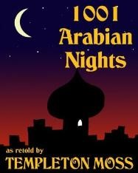  Key text: 1001 Arabian Nigh |  | Key text: |  | 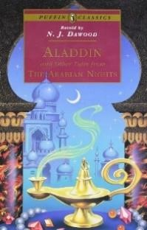  Key text: Focus on Aladdin. |  |  | Key text: Focus Ali Babar story |  |  | Key text:
Outcomes:  Focus on the famous stories th the children will have heard of Baba and the 40 thieves, Alad Sinbad the Sailor. Read a range of the Arabian Nights stories. Identify the common themes that run through most.  Collect and explore descriptive language.  Explore zone of relevance.  Pie Corbett style learning of Aladdin story. | , | Outcomes:  Rewrite of Aladdin story. Recap on dialogue and show not tell sentences.  Shared write of beginning of story. |  | Outcomes: Revise and practise using dialogue and conventions of speech to forward the action. Have a go at writing an opening to Aladdin that begins with dialogue. Children to use drama to show how a character’s inner most feelings can be portrayed without directly telling the reader. |  |  | Outcomes:  Read Ali Babar story and know it inside out, act out story, shared writing with partner and build a story plan. |  |  | Outcomes: Children to write up the story. Focus on an opening that begins with dialogue – straight into the action and using a range of show not tell sentences. Edit and improve.
Topic: Earth Explorers
Tier 2 vocabulary: glistened
relieved/relief concealed, occurred, eerie, impaled, perilous, deserted, luminous, drained,
Week 1 | Week 2 |  | Week 3 |  |  | Week 4 |  |  | Week 5
Key text: Alex Ryder Point Blanc | Key text: Alex Ryder Point Blanc continued |  | Key text: Alex Ryder  Point Blanc continued |  |  | Key text: The Great Kapok Tree |  |  | Key text:  The Great Kapok Tree continued

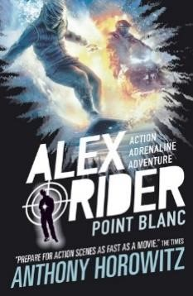 |  |  |  |  |  | 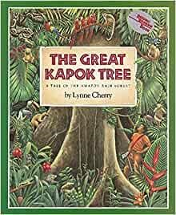
Outcomes:  Read Alex Rider book 2 where he is escaping from a mountain.  Explore different mountain range pictures and collect vocabulary  Read some other adventure stories with a descriptive setting for example Charlie Small Valley of Terrors. | Outcomes: Discuss the features of an action story and how to build up tension. Support children to plot out an opening, build up and problem on a mountain side. | Outcomes: Write their own adventure stories (not full story) with a focus on setting the scene (opening) and building up suspense  (climax |  |  |  | Outcomes: Focus on  explanations: reading and looking for features of genre. Read and research about the rainforests. Read explanations about layers of the rainforest  Read ‘The Great Kapok Tree’ which explores issues of deforestation. |  | Outcomes:  Write an explanation text about deforestation. Use arguments for and against deforestation.
Topic: Project Birmingham  Tier 2 vocabulary: persuade | e, convince, argue, justify, efficiently, effectively, productively
Week 1 |  |  |  |  | Week 2
Key text: Fairy Tales/Revolting  Recap of traditional tales | Rhymes |  |  |  | Key text:  Non-fiction/information texts about different key services with Birmingham City Council.  Range of examples of persuasive language, both written and oral eg transcripts from election campaign speeches.
Outcomes:  Look at traditional Tales and t danger: Red Riding Hood, Gold goody/baddy? What was the p  Identify features of persuasive Modelled write: the children persuading the council they sh  house, e.g. three little pigs, 3 b  Alternative: use Revolting Rhy someone that RRH was really | eir origins. Think about stranger ilocks… Who was the urpose of these stories?  writing. will write as a fairy tale character, ould have money to rebuild their  ears, Red Riding Hood.  mes as stimulus and persuade a bad character. |  |  |  | Continue with persuasion, linking this to Birmingham City Council/project Birmingham. Children have explored some different areas that need funding in our city – education; fire dept; police; parks services; environmental services; transport; and housing.  The council are awarding money to different departments and children need successfully gain the winning bid with their speech.  Outcome: Persuasive speech. Children to write a speech, persuading Birmingham City Council to give the winning bid to their area of need. Use of persuasive language features, direct address, formality modal/imperative verbs. These speeches will be performed to the “Council” (SLT, or visitors such as local councillors etc).
Topic: Star Trek  Tier 2 vocabulary: glitch, for | med, accelerate, intergalactic, interstellar, transmitting, launching, futuristic,
conventional, potential, nes | tled, communication
Physical Oracy:  Gestures become increasingly natural |  |  |  | Social & Emotional Oracy:  Speak with flair and passion
Cognitive Oracy:
Identify when a discussion is going off topic and be able to bring it back on track with support and use of sentence stems e.g. That might be true, but what do you think about …?
Week 1 | Week 2 |  | Week 3 |  |  |  | Week 4 |  | Week 5
Key text: Dr Maggie’s Gran Tour of the Solar System 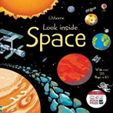 | Key text:  Series of information texts about the Solar System; Earth, Sun,  Moon; the seasons; |  | Key text:  There are a range of Sci Fi stories in the Y5 classroom/use of visual literacy clips. |  |  |  | Key text: There are a range of Sci Fi stories in the Y5 classroom/use of |  | Key text:  There are a range of Sci Fi stories in the Y5 classroom/use of visual literacy clips.
Usborne Look Inside Space  Series of information texts about the Solar System; Earth, Sun, Moon; the seasons; night and day for children to research from and look at the features of. There is a box of these in Y5 classroom and in US library.  Explore Non-fiction features/information texts – build upon the learning from Shakespeare topic.  Read a series of information/explanation texts about Science learning - the solar system, different planets, how night and day/seasons are formed.  High-quality writing through topic.  Write up Science learning (eg about night and day; the Earth, Sun and Moon) as high-quality information paragraphs (rather than a whole report). Develop children’s use of Alan Pete sentence types for information writing (eg the  different use of colon in a De:de sentence; embedded  clauses; dashes for parenthesis). | children to research from and look at the features of. There is a box of these in Y5 classroom and in US library.  Outcomes:  High quality writing through topic.  Still carry on in one-off sessions writing up information about Science learning.  Non-fiction writing:  Learn information about space and planets.  Research and take notes |  | Outcomes:  Children to write a supported, structured paragraph about space/planets.  Edit and improve.  Then, paired writing about space/planets using Sage and Scribe. |  |  |  | visual literacy clips.  Outcomes: Independent paragraphs about space/planets using knowledge  of structure,  grammar and punctuation from structured writing and paired writing. |  | Outcomes:  Poetry -  Pie Corbett’s Space  Poems  Children perform “The  Rubbish Tip Alien”  Focus on simile/metaphor/literary techniques.  Children explore “6 ways to look at the moon” Children explore lots of different visuals about the moon- children rewrite the poem using their own analogies/imagery. Or some children to choose their own space feature (the milky way/the night sky/the earth from space etc) and create their own version of the 6-line poem.

Topic: Busy Biologists
Tier 2 vocabulary: companion, fascinating, impact, discoveries, ground-breaking, revolutionise, adventurous, determined, dedicated, leash, grim, observing
Week 1 | Week 2 | Week 3 | Week 4
Key text:  Read lots of examples of biographies of | Key text: Continue The Story of Jane Goodall | Key text: Continue The Story of Jane Goodall | Key text:  Performance poetry.

naturalists/conservationists/wildlife experts.  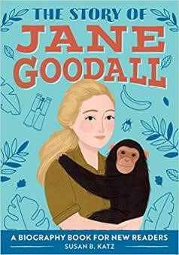  Jane Goodall Biography  Or David Attenborough  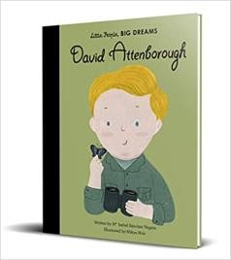  Biography  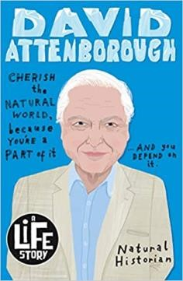 |  |  | Brian Moses “I’m Walking With My Iguana”.  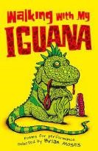
Outcomes:  Re-cap the features of a biography – language/structure/layout. Shared reading of a range of examples of naturalists/conservationists/wildlife experts.  Research a given wildlife expert. Children develop use of direct vs reported speech and include it in their biographies.  Children write a biography about their naturalist/conservationist/wildlife expert. | Outcomes:  Re-cap the features of a biography – language/structure/layout. Shared reading of a range of examples of naturalists/conservationists/wildlife experts.  Research a given wildlife expert. Children develop use of direct vs reported speech and include it in their biographies.  Children write a biography about their naturalist/conservationist/wildlife expert. | Outcomes:  Children visit the Butterfly Farm.  Children use their own images from the trip and the information they have learnt to produce a visitor information guide/or produce an information poster or fact file about Butterflies in Britain. Third person, verb choice, impartial language. Include a section about specific British butterflies they are learning about this week in Science eg. Giant Blue Butterfly. Include a section about the life cycle of a butterfly, learnt about in Science.  Re-cap features of this type of writing from | Outcomes:  Children explore the poem and identify rhyme, rhythm and structure – consider how  it is written to be spoken, rather than read.  Children perform the poem considering tone, intonation and inflection.  Children develop and perform their own “animal poem” based on the structure and concept of Walking With My Iguana.
 |  | Snowdonia leaflets – they should apply this independently

