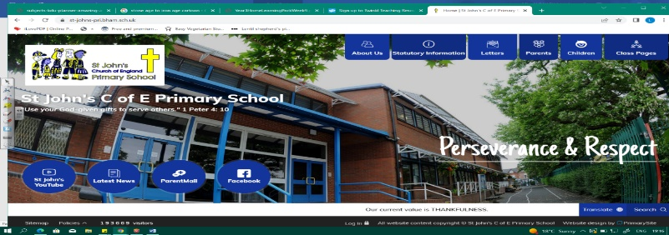
Health Heroes
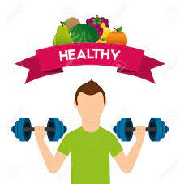
During this unit, we will develop our knowledge about our bodies from Year 1 (Our Story). We will discover what humans and animals need to survive and what kinds of food we should eat to live in a healthy way. We must think about why we should exercise and how to keep our bodies clean. We will also investigate what plants need to live and carry out tests to find out.
Working Scientifically
During this unit, we can improve our skills in:
- identifying and classifying
- gathering and recording data to help in answering question
- observing closely, using simple equipment
- using their observations and ideas to suggest answers to questions
Can you answer these questions at the end of this unit?
Science  - What do humans need to survive?  - Why is it important that we exercise?  - Why is it important that we clean ourselves? | - Would I be healthy is all I ate was salad?  - What to bulbs and seeds need to grow?  - Do plants grow well in a dark room? How could we test it?
offspring | survival | exercise | hygiene | seeds | bulbs | mature
temperature | food groups | carbohydrates | protein | fruit | vegetables | sugar | fats
Key Vocabulary (Tier 3)

English
We will focus on food poems and read Michael Rosen’s Mustard, Custard, Grumble Berry and Gravy. We will then read Food Poems before writing our own poetry.
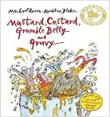  inventor medals  scramblers | 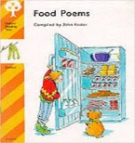  shelves spreads bib  supper beansprouts
Key English Vocabulary (Tier 2 and 3)

