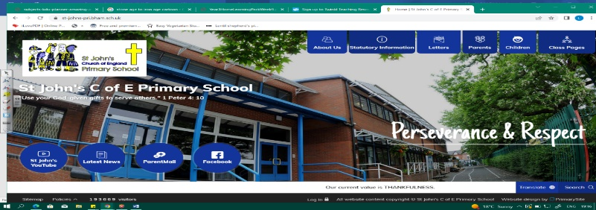
Go Wild
During this unit, we must become scientists and geographers! We will explore living things, habitats and microhabitats. Our learning about animals in Year 1 (Wild Safari) and EYFS will help us.
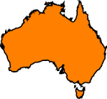
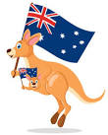
We will then travel to Australia! We will find where it is using maps and learn about its continent and capital. We must discover more about Australia’s climate, landscape, animals and where people live and why.
Working Scientifically During this unit, we can improve our skills in:
- asking simple questions and recognising that they can be answered in different ways
- identifying and classifying
Can you answer these questions at the end of this unit?
Science  - What equipment might I use to study a microhabitat?  - Where might I find a woodlouse’s microhabitat?  - What do animals need to stay alive and healthy?  - What is a habitat? | Geography  - Where in the world is Australia? Show on a map. In which continent is Australia? What is the capital of Australia?  - What is the climate like in Australia?  - What is a biome? Can you give an example of one in Australia?  - What does population mean? Why do lots of people live near the coast in Australia?
living | dead | habitats | microhabitats | survival | food chain |  |  | food sources |  | shelter
classification |  | climate | southern hemisphere | northern hemisphere |  | biome | vegetation |  | landscape
Key Vocabulary (Tier 3)
English
We will learn about Aboriginal dreamtime stories and will focus on Tiddalick the Greedy Frog. We will then read The Magic Boomerang by Frané Lessac and write our own magic boomerang adventure!
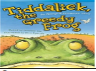  power spun sway legends boomerang | 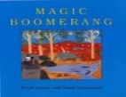  creation discovered  valley Billabong
Key English Vocabulary
(Tier 2 and 3)

