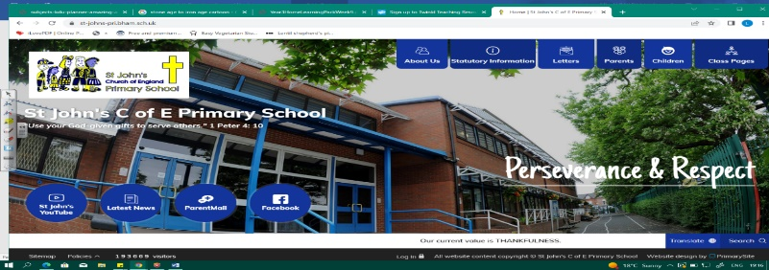
Suitcases and Sandcastles
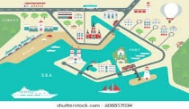
During this unit, we will become geographers! Our learning about seasides in EYFS and work on Does Chocolate Grow on Trees will help us to read and understand more detailed maps. We will think about human and physical features of geography and have fun exploring sea side/coastal towns.
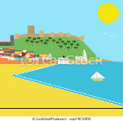
As we study Katie Morag stories, we must also become experts on Scotland! In history, we travel back in time to find out what seaside holidays were like for the Victorians.
Can you answer these questions at the end of this unit?
Geography  - Can you name some seaside towns in the UK? Find them on a UK map!  - Where is Scotland? Can you show it on a map? What is the capital of Scotland?  - What human and physical features of geography might I find in a seaside town?  - How can you keep safe when near the sea? | History  - Who were the Victorians, who are the named after and when did they live?  - How are our holidays different from the Victorians’ holidays in Britain?
human geography | physical geography | coast | beach | port | harbour
compass points | island mainland | cliff | population | pier | bay
Key Vocabulary (Tier 3)

English
We will study The Lighthouse Keeper’s Lunch by Rhonda and David Armitage and the Katie Morag series by Mairi Hedderwick, before retelling Katie Morag and the Two Grandmothers with our own ending!
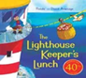  cottage perched lighthouse industrious | 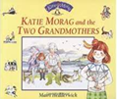  bay village mainland island ferry wee trailer
Key English Vocabulary (Tier 2 and 3)

