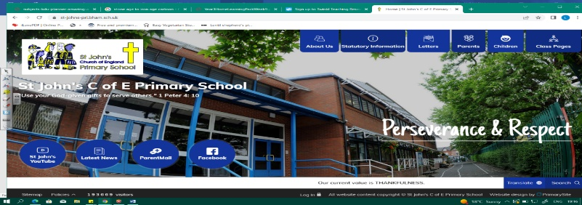
Superheroes
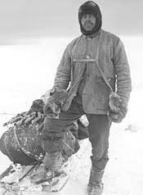
During this unit, we will learn about famous explorers and humanitarians, who they were and what they achieved. We will become skilled geographers as we look at their journeys on maps and explore places like Mount Everest. Our learning in Let’s Go Engineering will help us as we look at Robert Falcon Scott’s Antarctica explorations.
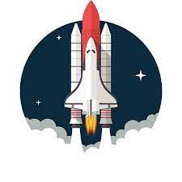
In history, we must study sources and what they tell historians about the past. We will be inspired to think about how we can make a difference to our world!
Can you answer these questions at the end of this unit?
History  - What is an explorer and what is a humanitarian? Name a famous explorer and a famous humanitarian. When did he/she live?  - How have these people made the world a better place?  - Why do historians argue over how Columbus should be remembered?  - Name sources that tell us about explorers. | Geography  - Name an explorer. Where did he/she go? Show on a world map.  - Where in the world is Mount Everest? What is the name of the mountain range Everest is part of?  - Describe some physical features of Antarctica
history within living memory |  | chronological | explorer |  | humanitarian |  | equipment | log
voyage | founded | continent |  | mountaineer |  | climate |  | environment
Key Vocabulary (Tier 3)
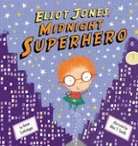
English
We will begin by reading non-fiction texts to research famous explorers. Then, when acting out the moon landing, we will write our own space log. Finally, we will read Elliot Jones: Midnight Superhero by Anne Cottringer, before retelling the story with an alternative ending.
mayor | rampaging | towering | glaciers
coast guard | sleuth | Himalayas | lion tamer
Key English Vocabulary (Tier 2 and 3)

