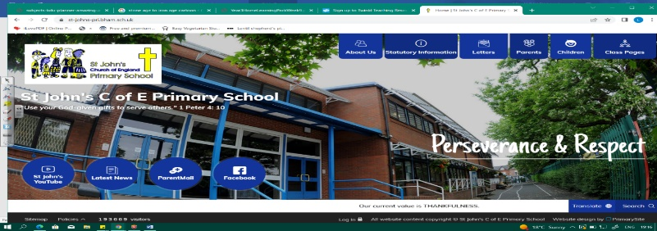
Does Chocolate Grow on Trees?
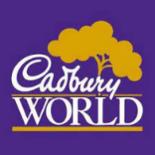
During this unit, we will find out where chocolate comes from! We will learn about the Cadbury family in Birmingham, when and where they lived and the legacy they left. We will then travel to Mexico to discover who the Aztecs were and what they gave to the world.
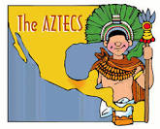
In geography, we will learn where Mexico is and what it is like. Our learning in this unit will help us as we learn about more empires and civilisations in KS2.
Can you answer these questions at the end of this unit?
History  - When did Cadburys begin their company?  - What did the Cadbury family give to Birmingham and Bournville?  - Who were the Aztecs, where and when did they live?  - How do historians know about the Aztecs?  - What legacy did the Aztecs leave? | Geography  - How has Bournville changed since the 1800s?  - Where is Mexico? Show on a world map. In which continent is Mexico? What is the capital city called?  - What is the climate/weather like in Mexico?  - Why did the Aztecs settle in modern Mexico City?
factory | Aztecs | empire | civilisation | source | chronological
settlement | population | marshland | floating gardens | equator | continent
Key Vocabulary (Tier 3)
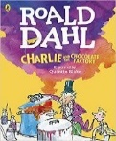
English
We will read Roald Dahl’s Charlie and the Chocolate factory, though our main focus will be adverts for Cadbury’s chocolate. As we study persuasive language, we will create our own advert for a chocolate bar. We will also write a set of instructions for how to make an Aztec mask.
elevator | belching | pandemonium | delightful | mouth-watering
delicious | creamy | scrumptious | delicate | dreamy
Key English Vocabulary
(Tier 2 and 3)

