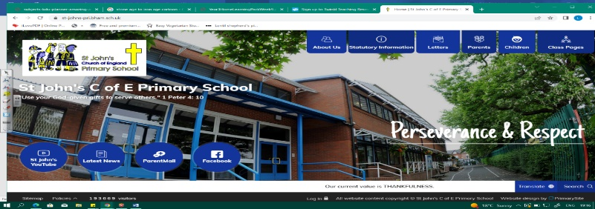
Let’s Go Engineering!
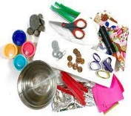
During this unit, we will build on our knowledge of materials from Year 1. We will find out more about different types of materials, their properties and what we use them for. As scientists we must begin to ask questions and test different types of materials.

In geography, we will learn about the North and South Poles and Antarctica, using maps and globes. We will begin to understand how the equator affects climate.
Working Scientifically During this unit, we can improve our skills in:
- asking simple questions and recognising that they can be answered in different ways.  - observing closely, using simple equipment. | - performing simple tests  - identifying and classifying  - gathering and recording data to help in answering questions.
Can you answer these questions at the end of this unit?
Science  - Out of the following materials, which ones can change shape: plastic, glass, brick, or paper?  - If I was building a house, which material should I use and why?  - Which material was best at insulating your ice cube?  - How did you present your data and why? |  | - Where in the world are the North and South Poles? Show on a map.  - Where is the equator? Where are the hottest countries in the world? Where are the coldest countries in the world?  - How is Antarctica different from where we live? What lives there? Can anything grow there?
solid | opaque |  | transparent |  | translucent | surface | texture |  | reflective |  | insulation
waterproof |  | flexible |  | rigid | equator | North Pole |  | South Pole |  | Antarctica |  | climate
Key Vocabulary (Tier 3)

English
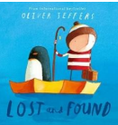
We will begin with a focus on non-fiction leaflets about a local science museum. We will then write up the results of our science experiments on materials. Our main text will be Lost and Found by Oliver Jeffreys, as we look at descriptive language and retell the story.
ignored | lonely | harbour | South Pole | disappointment
Key English Vocabulary (Tier 2and 3)

