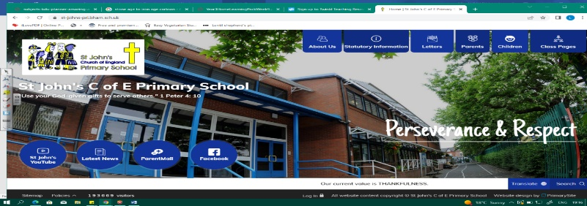
Fire Fighters
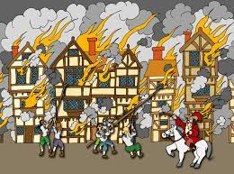
During this unit, we will learn about the Great Fire of London in 1666. We will explore when and how it happened, and how historians know about it. Our learning in Year 1 (Whizz, Bang, Pop) will help us as we find out more about the Tudors, what London was like and how their fire service was different to ours.

In geography, we will find important landmarks in London and understand where it is in the UK.
This unit will help us to prepare for Year 5 when we study the Tudors even more!
Can you answer these questions at the end of this unit?
History  - What does chronological mean?  - How was London different in 1666 from today?  - How are the fire services different?  - How do we know about the Great Fire? Can you name some sources?  - What do historians say about how the fire started? | Geography  - Name the 4 countries that make up the UK. What are their capital cities? In which continent is the UK?  - What are the surrounding seas of the UK called?  - What is a landmark? Names some famous landmarks in London.
history within living memory | history beyond living memory | chronological | source | eye-witness | Tudor
The Plague | city | country | continent | map | landmark
Key Vocabulary (Tier 3)

English

We will read Michael Bond’s Paddington Bear and write postcards to Paddington. We will then read non-fiction leaflets about Hamleys, as we write our own. We will then act out the events of the Great Fire of London before writing an account of it, and finish the unit with fire safety posters!
tourist | tube | tour | scrapbook | Buckingham Palace
Madame Tussauds | Tower of London | diary | government | Parliament
Key English Vocabulary
(Tier 2 and 3)

