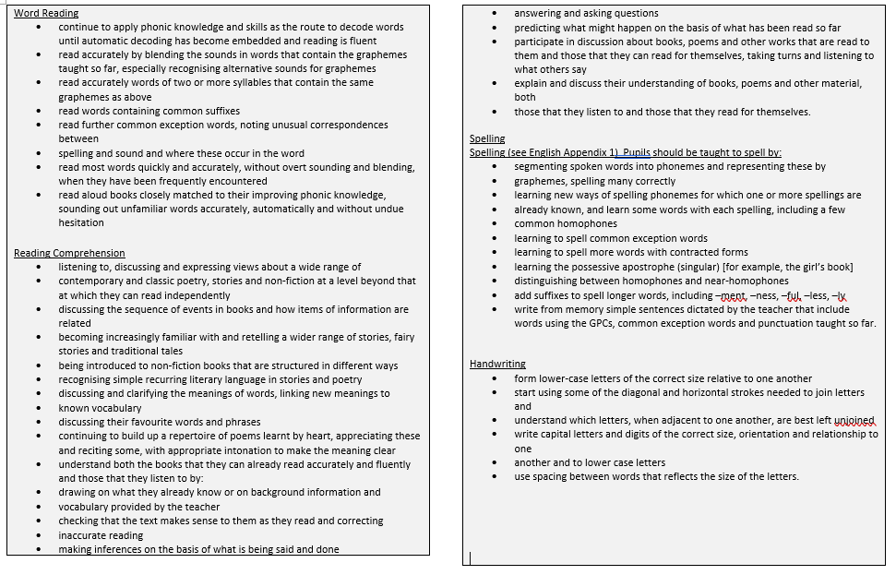

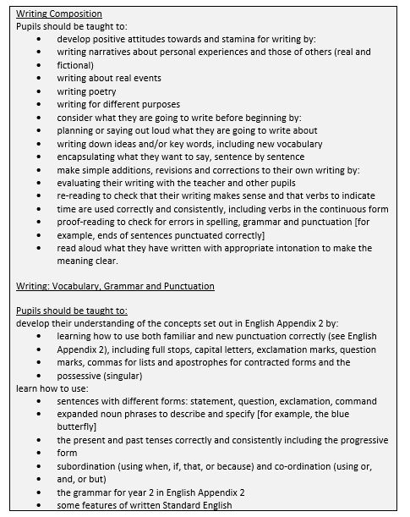
YEAR 2 ENGLISH OVERVIEW
Alan Peat sentence types to be taught in English: All the Ws; List sentences; 2Ad sentences; short sentences.
Topic: Firefighters
Key Text: Paddington’s London Treasury (F)
Tier 2 vocabulary: city, tourists, train, tube, tour
Tier 3 vocabulary: scrapbook, Buckingham Palace, Madame Tussauds, Tower of London, London Bridge

Key Text: Samuel Peyps’ Diary (NF)
Tier 2 Vocabulary: diary, wig, government,
Tier 3 Vocabulary: quill, Navy, Parliament, eye witness

Recount: enjoyed, favourite, wonderful, amazed
Oracy Autumn Term
Physical Oracy:  Speak clearly and confidently with appropriate volume and pace in a range of contexts. |  |  |  | Linguistic Oracy:  Speaking in sentences using joining phrases to create longer sentences, through help to use conjunctions and sentence stems in speech and writing.
Cognitive Oracy:  Ask questions to find out more about a subject |  |  |  | Social & Emotional Oracy:  Start to develop an awareness of audience e.g. what might interest a certain group
Week 1 | Week 2 |  | Week 3 |  |  | Week 4 |  | Week 5
Key text: Paddington’s Guide to London  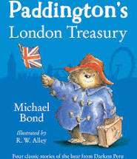 | Katie in London James Mathew  A day in London Rodrick Hunt |  | Key text:  Fire fighter’s visit school. |  |  | Key text:  Look at a range of posters. Research about fire safety using videos. |  | Key text:  Samuel Peyps Diary (Kids’ non-fiction book)  Non – Fiction Focus Great Fire of London  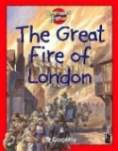
Outcomes:  Postcard to Paddington bear after a trip around London (Artis DRAMA). | Outcomes: Children to find out more about London. Use Artis to role play going to London. Write a diary about their trip to London. |  | Outcomes:  Recount of the Fire Fighters visit to school. |  |  | Outcomes: Learn about fire safety.  Outcomes: Make a fire safety poster.
Topic: Let’s Go Engineering!

Key Text: Lost and Found (F)
Tier 2 Vocabulary: ignored, lonely, harbour
Tier 3: South Pole, disappointment

Adjectives to describe settings: dark, terrifying, windy, calm
Feelings words: confused, puzzled, annoyed, tearful, upset, thrilled, delighted
Week 1 |  | Week 2 |  |  | Week 3 |  | Week 4
Key text: Children will look at the features of a leaflet from a local Science museum.   |  |  |  |  | 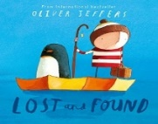  Key text: Lost and Found : |  | Key text: Lost and Found continued
Outcomes: Understand the features and purpose of a leaflet. Make a leaflet about different materials and their properties. |  | Outcomes:  Write up science investigation about materials in their leaflet. |  |  | Outcomes: Use Artis to explore the story. Children to understand how the feelings of the characters change throughout the story. Children to plan alternative middle and ending. |  | Outcomes: Children to write and alternative middle and ending to the story.
Topic: Does Chocolate Grow on Trees?
Key Text: Charlie and Chocolate Factory (F)
Tier 2 Vocabulary: factory, inventions, elevator
Tier 3 Vocabulary: furnace, belching, pandemonium

Feelings and descriptions: peculiar, delightful, colourful, mouth-watering, disgusting, delicious, sweet, tasty.
Sense descriptions: rough, smooth, sugary, sour, soft, chewy, rich, cream, powdery
Descriptions of taste: creamy, rich, scrumptious, delicious, smooth, delicate, melt-in-mouth, dreamy.
Week 1 | Week 2 |  | Week 3 |  |  | Week 4 |  | Week 5
Key text: Trip to Cadbury World | Key text: 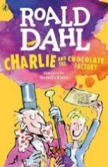 |  | Key text: Cadbury adverts  https://www.campaignlive.co.uk/the-work/advertiser/cadbury/7073 |  |  | Key text: Read a range of instructions to make, build things |  | Key text: Travel brochures.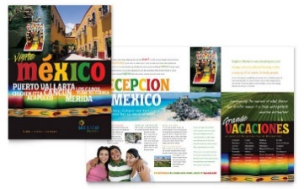
Outcomes: Recount of children’s trip to Cadbury world. | Outcomes: Setting description focus. Children to experience ‘candy land’ from the story and write a setting description. |  | Outcomes: Watch a range of Cadbury adverts throughout history. Children to create their own Cadbury advert for dairy milk chocolate. |  |  | Outcomes: Children to write instructions about how to make an Aztec mask. |  | Outcomes: Artis session of flight to Mexico and sightseeing in Mexico. Children to write their own travel brochure about what they saw, weather, tourist attractions etc.
Topic: Superheroes

Key Text: Elliot Jones: Midnight Superhero (F)

Tier 2 Vocabulary: mayor, rampaging, towering
Tier 3 Vocabulary: glaciers, lion tamer, coast guard, sleuth, Himalyas

Key Text: Big Cat – Where on Earth? (NF)
Tier 2 Vocabulary: route, raiders, mission
Tier 3 Vocabulary: continents, Vikings, Polynesians

Descriptive: golden, jaggy, sharp, clear, blowing, blustering, fluffy, crackling, crunchy, freezing.
Craters, launch, adventure

Oracy Spring Term
Physical Oracy:  Gestures start to become natural to support speech e.g. gesturing towards someone if referencing their idea. |  |  |  | Linguistic Oracy:  Adapt how to speak in different situations according to the audience.
Cognitive Oracy:  Build on others’ ideas in discussions |  |  |  | Social & Emotional Oracy:  Show awareness of others who have not spoken and invite into the discussion e.g. saying their name, asking them a question, turning to them.
Week 1 | Week 2 |  | Week 3 |  |  | Week 4 |  | Week 5
Key text: Big Cat Collins. Where on Earth?  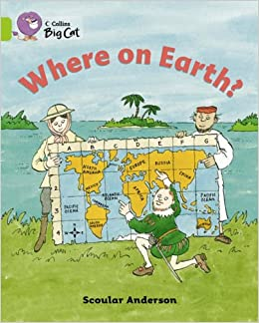 | Key text: Clips from Neil Armstrong’s flight to the moon. |  | Key text: Eliot Jones Midnight Superhero  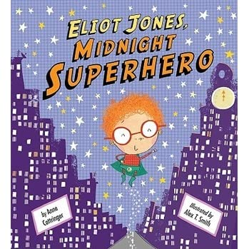 |  |  | Key text: Continue Eliot Jones Midnight Superhero. |  | Key text: Instructional texts
Outcomes: Research Edmund Hillary (Everest),  Amundson and Scott of the Antarctic,(raced to the Antarctic)  Ferdinand Magellan (first to sail around the world)  Artis Session to explore descriptive language:  Visit the following (in the hall with props and images)  - Antarctic  - Everest  - Carribean | Outcomes:  Year 2 Trip to the Moon!  Watch videos of space launch 1969.  Children to dress up in space suits, have headsets and American flags. Act out the Launch to the moon on 16th July 1969. Children to write their own space log as if they are Neil Armstrong. |  | Outcomes:  Act out the story using talk for writing. Retell the story. |  |  | Outcomes: Plan an alternative middle and ending of the Eliot Jones story. |  | Outcomes: Children to write instructions about how to make a rocket for Eliot Jones.
Topic: Suitcases and sandcastles

Key Text: Katie Morag books (F)
Tier 2 vocabulary: bay, village, mainland, island, ferry, wee, trailer
Tier 3 vocabulary: pier, bay

Key Text: The Light House Keepers Lunch (F)
Tier 2 vocabulary: cottage, perched, lighthouse, industrious
Tier 3 vocabulary: cliff
Week 1 |  | Week 2 |  |  | Week 3 |  | Week 4
Key text:  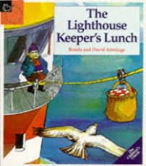 |  | Key text: Visit from Katie Morag  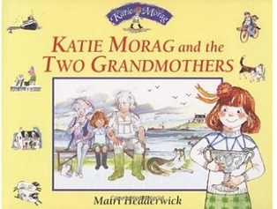 |  |  | Key text: Explore a range of Katie Morag texts. 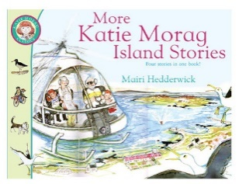 |  | Key text: Continue Katie Morag texts. 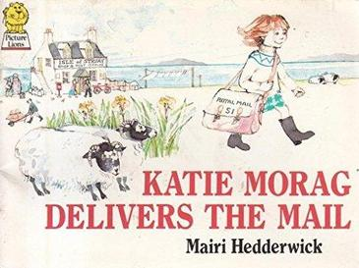
Outcomes: Instructions for making a sandwich.  Retell the story of the Lighthouse Keeper’s Lunch. |  | Outcomes:  Letter to Katie Morag about Birmingham |  |  | Outcomes: retell the story of Katie Morag and the Two Grandmothers using talk for writing text map. |  | Outcomes: Plan and write an alternative middle and ending of a Katie Morag story.
Topic: Go Wild!

Key Text: The Magic Boomerang (F)
Tier 2 vocabulary: vocabulary: power, spun, sway
Tier 3 vocabulary: legends , boomerang

Key Text: Tiddalick the Greedy Frog
Tier 2 vocabulary: creation, discovered
Tier 3 vocabulary: valley, Billabong
Oracy Summer Term
Physical Oracy:  Use body language to show active listening and support meaning when speaking e.g. nodding along. |  |  |  | Linguistic Oracy:  Use sentence stems to signal when they are building or challenging others’ ideas in groups.
Cognitive Oracy:  Make connections between what has been said and their own and others’ experiences |  |  |  | Social & Emotional Oracy:  Recite/deliver short pre-prepared material to an audience (Year Group CW Performance)
Week 1 | Week 2 |  | Week 3 |  |  | Week 4 |  | Week 5
Key text: Tiddalick the Greedy Frog  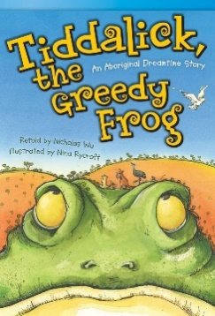 | Key text: Taddalick the Greedy Frog continued |  | Key text: The Magic Boomerang  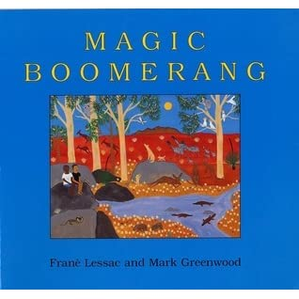 |  |  | Key text: The Magic Boomerang continued. |  | Key text: Scrap books
Outcomes: Watch and discuss Australian dreamtime stories.  https://www.youtube.com/watch?v=93UIsjYz75k (how the birds got their colours 0:34)  https://www.youtube.com/watch?v=2AaTezKHmLQ (how the moon was created)  https://www.youtube.com/watch?v=itszep0duwI  (why Koala has a stumpy tail)  https://www.youtube.com/watch?v=O3TkE0Ke15M (Tiddalick)  Character descriptions of the frog and the owl. | Outcomes: Children to pick their own wise character and their own greedy character to adapt the story of Taddalick. |  | Outcomes: Children to plan their own magic boomerang adventure. Think of a place that the boomerang will take them and a problem that will occur in that place. |  |  | Outcomes: Children to write their magic boomerang story. |  | Outcomes: Children to create their own scrapbook as if they have visited Australia.
Topic: Health Heroes
Key Text: Mustard, Custard, Grumble Berry and Gravy (poetry)
Tier 2 vocabulary: inventor, medals,
Tier 3 vocabulary: scrambler

Key Text: ORT - Food Poems (poetry)
Tier 2 vocabulary: shelves, spreads, bib
Tier 3 vocabulary: supper, beansprouts
Week 1 | Week 2 |  | Week 3 |  |  | Week 4 |  | Week 5
Key text: Mustard, Custard, Grumble Berry and Gravy  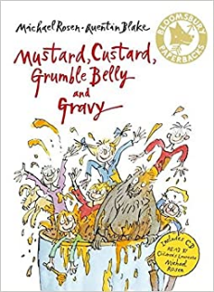 | Key text: ORT Food poems  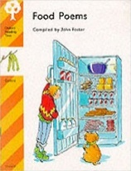 |  | Key text: Poetry continued. |  |  | Key text: Poetry continued |  | Key text:
Outcomes:  Focus on the poem Don’t by Michael Rosen and build up class poem using alliteration. | Outcomes: Focus on the ‘In The Fridge’ poem. Children to collect vocab from different foods. |  | Outcomes: Children to create their own ‘In the Fridge’ or ‘Don’t’ poem. |  |  | Outcomes: Perform poems. |  | Outcomes:

