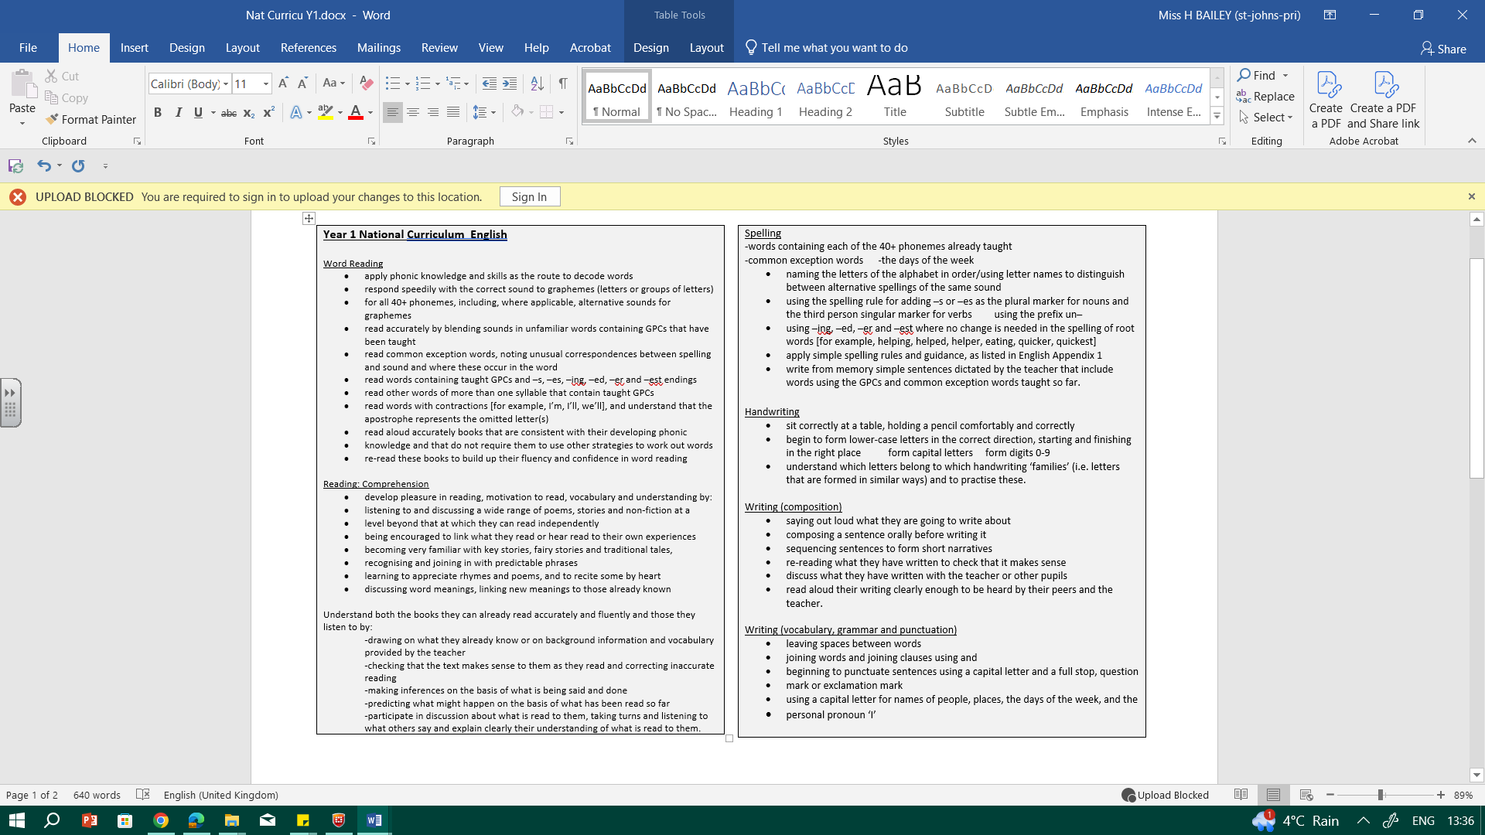

Topic: Our Story Tier 2 and 3 vocabulary (see each text)

Sentence Structure:
-Colourful Semantics: Orange is WHO, yellow is a DOING word (verb) and green is THING or PERSON (noun).
-Capital Letters at the beginning of a sentence, finger spaces and full stops at the end.
-Say the sentence before writing (use phonics)

Genre Fiction and non-fiction (my body).
Oracy Autumn Term
Physical Oracy:  Speak clearly and confidently in a range of contexts. |  |  |  |  |  |  |  |  |  | Cognitive Oracy:  Offer reasons for their opinions
Linguistic Oracy:  Speak in full sentences (modelled by staff and repeated by children) |  |  |  |  |  |  |  |  |  | Social & Emotional Oracy:  Listen and respond appropriately to others
Week 1 |  | Week 2 |  | Week 3 |  |  |  |  |  | Week 4 |  |  | Week 5
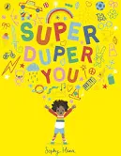  Key text: Super Duper You!  T2/3: spotted, stomp, limit, proud, bold |  | 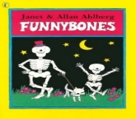  Key Text: Funny Bones  T2: town, skeleton, bone |  | Continue Funny Bones. |  |  |  |  |  | Key Text: My Body  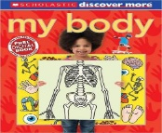  T2/3: senses, bone, skeleton, body |  |  | Continue My Body.
Outcomes: Say and begin to write ‘I am…/ I like…’ sentences  (Initial writing assessment) |  | Outcomes:  Say a sentence and write it down.  Settings  (The skeleton is in the park..) |  | Outcomes:  Use capital letters and full stops to construct simple sentences.  (The skeleton is jumping…) |  |  |  |  |  | Outcomes:  Non-fiction (reading focus).  Use a ? to write a question.  (My body can…  My body needs….? |  |  | Outcomes: Build simple sentences to make a ‘My Body’ book.
Topic: Whizz Bang Pop Tier 2/3 vocabulary: (see each text)

Sentence Structure:
-Colourful Semantics: Orange is WHO, yellow is a DOING word (verb) and green is THING or PERSON (noun).
-Capital Letters at the beginning of a sentence, finger spaces and full stops at the end.
-Say the sentence before writing (use phonics)

Genre Fiction (exploring story structure and description) Poetry
Week 1 |  | Week 2 |  | Week 3 |  |  |  |  |  | Week 4 and Week 5
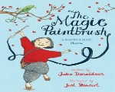  Key texts: The Magic Paintbrush  T2/3: gather, slips, spreads, seashore, weeping, bellows, seize, scowls |  | Continue The Magic Paintbrush |  | Key text: Special Days Poems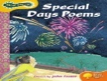  Tony Milton Fireworks  T2/3: darkness, showers, sparks, clutch, sprinkle |  |  |  |  |  | Diwali Story:  https://www.bbc.co.uk/cbeebies/stories/lets-celebrate-diwaliperformance  T2/3 Light, candle, celebrate, religion,
Outcomes: Order events of the story.  Role play the story. |  | Outcomes: Use descriptive words in sentences.  Purple CS cards in sentences. |  | Outcomes: Explore and write simple onomatopoeia poems (sound words). |  |  |  |  |  | Outcomes: Act out story with shadow puppets. Focus on beginning, middle and end/retelling the story.
Topic: Wild Weather Tier 2 vocabulary: (see each text)

Sentence Structure:
-Colourful Semantics: Orange is WHO, yellow is a DOING word (verb) and green is THING or PERSON (noun).
-Capital Letters at the beginning of a sentence, finger spaces and full stops at the end.
-Say the sentence before writing (use phonics)

Genre
Fiction Poetry
Week 1 |  | Week 2 |  |  | Week 3 |  |  | Week 4 |  |  |  | Week 5
Key texts:  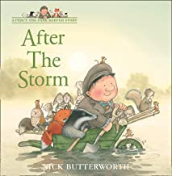  Percy the Park keeper: After the Storm  T2/3: raging, pouring, inspect, wreaked, stumbled, admire |  | Continue work on Percy the Park keeper: After the Storm |  |  | Key text: Leaf Man  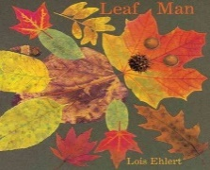  T2/3: gather, great, stick, enormous |  |  | 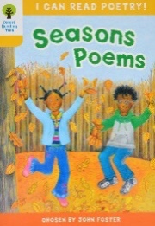  Key texts: Seasons ORT poems  T2/3: sight, blossom, bare, plain, ghostly, beneath, fiercely, harvest |  |  |  | Continue Seasons poems
Outcomes:  Explore adding -ing suffix to words (SPAG)  Yellow CS cards. |  | Outcomes:  Explore story structure (beginning, middle and end)  Retell the story (using ing suffixes) |  |  | Outcomes: Make a leaf character. Use adjectives to describe and build sentences using adjectives about the character.  Verbally think of stories about the leaf characters- model a story map for story structure. Beginning- problem- solution- end. |  |  | Outcomes: Exploring senses of different seasons and building up vocabulary |  |  |  | Outcomes: Sensory season poem.
Topic: Waste Warriors Tier 2/3 vocabulary: (see each text)

Sentence Structure:
-Colourful Semantics: Orange is WHO, yellow is a DOING word (verb) and green is THING or PERSON (noun).
-Capital Letters at the beginning of a sentence, finger spaces and full stops at the end.
-Say the sentence before writing (use phonics).

Genre
Fiction
Visual literacy
Non-fiction: persuasive leaflets (layout of leaflet and persuasive writing e.g. bossy verbs and !)
Oracy Spring Term
Physical Oracy:  Continue to use gesture to support delivery e.g. pointing at parts of a plant they are discussing. |  |  |  |  |  |  |  |  |  | Linguistic Oracy:  Using vocabulary appropriately specific to the topic
Cognitive Oracy:  Recognise when they haven’t understood something and ask a question |  |  |  |  |  |  |  |  |  | Social & Emotional Oracy:  Be willing to change their mind based on what they have heard
Week 1 |  | Week 2 |  |  | Week 3 |  |  | Week 4 |  |  |  | Week 5
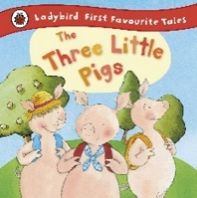  Key texts: The Three Little Pigs  T2/3:  Bold, piled, chin, huff, puff, squeaked |  | Continue with The Three Little Pigs |  |  | Key texts: The Trouble with Dragons  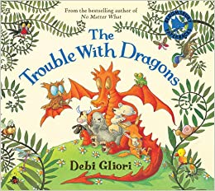  T2/3: spreading, greatest, trouble, expand, galore, puncture, atmosphere |  |  | Continue with Trouble with Dragons |  |  |  | Visual literacy: Happy Feet  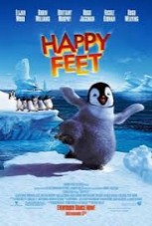  T2/3: abducted, mystic being, belongs
Outcomes: Act out the story with puppets. Explore the different materials in the story. Use adjectives to describe the materials. |  | Outcomes: Retell the story. |  |  | Outcomes: Explore the features of persuasion and leaflets. |  |  | Outcomes: Write leaflets about looking after the planet. |  |  |  | Explore persuasive posters (within science lessons)
Topic: Really Wild Safari Tier 2/3 vocabulary: (see each text)

Sentence Structure:
-Colourful Semantics: Orange is WHO, yellow is a DOING word (verb) and green is THING or PERSON (noun).
-Capital Letters at the beginning of a sentence, finger spaces and full stops at the end.
-Say the sentence before writing (use phonics).

Genre Fiction
Week 1 |  |  | Week 2 |  |  |  | Week 3 |  |  |  | Week 4
Key text: The Mixed-up Chameleon 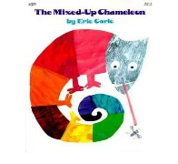T2/3: sparkling, hungry, weak, smart, |  |  | Continue The Mixed-up Chameleon |  |  |  | 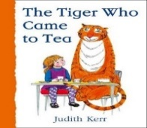  Key text: The Tiger Who Came to Tea  T2/3: suddenly, wonder, beginning, ring, |  |  |  | Key text: The Tiger Who Came to Tea
Outcomes: Retell the middle and end of the story. |  |  | Outcomes: Children to build own mixed-up animal. Describe own mixed-up animal. |  |  |  | Outcomes: Retell with a different animal that comes for tea. |  |  |  | Outcomes: Write an invitation, inviting their animal to tea at school.
Topic: Dungeons and Dragons Tier 2/3 vocabulary: (see each text)

Sentence Structure:
-Colourful Semantics: Orange is WHO, yellow is a DOING word (verb) and green is THING or PERSON (noun).
-Capital Letters at the beginning of a sentence, finger spaces and full stops at the end.
-Say the sentence before writing (use phonics).

Genre
Fiction Instructions
Oracy Summer Term
Physical Oracy:  Use appropriate tone of voice in the right context e.g. To project their voice to a large audience (Year Group CW Performance)  Use sentence stems to link to other’s ideas in group discussion |  |  |  |  |  |  |  |  |  | Linguistic Oracy:  Take opportunities to try out new language, even if it is not always correctly used.
Cognitive Oracy:  Disagree with someone else’s opinion politely.  Explain ideas and events in chronological order |  |  |  |  |  |  |  |  |  | Social & Emotional Oracy:  Take part in group discussions with an adult.
Week 1 | Week 2 |  |  |  |  | Week 3 |  |  | Week 4 |  |  |  | Week 5
Key text: Tell Me a Dragon  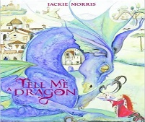  T2: ride, guard, curled, creep, fierce | Continue Tell Me a Dragon  Mummy Dragon leaves egg in classroom (chase the mummy dragon to give it back!). |  |  |  |  | Continue Tell Me a Dragon.  Build dragon catcher net to catch Mummy dragon. |  |  | Key text: Sir Charlie Stinky Socks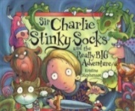  T2: groaned, moaned, surrounded, bold. |  |  |  | Continue Sir Charley Stinky Socks
Outcomes: Use adjectives to describe appearance and character of own dragon. | Outcomes: Wanted poster to catch mummy dragon, using descriptive sentences from previous week too. |  |  |  |  | Outcomes: Instructions to trap a dragon. |  |  | Outcomes: Use drama to act out the story. |  |  |  | Outcomes: Retell the story. Use simple sentences to build a narrative.
Topic: Green Fingers

Sentence Structure:
-Colourful Semantics: Orange is WHO, yellow is a DOING word (verb) and green is THING or PERSON (noun).
-Capital Letters at the beginning of a sentence, finger spaces and full stops at the end.
-Say the sentence before writing (use phonics).

Genre
Fiction Non-fiction
Week 1 | Week 2 |  |  |  |  | Week 3 |  |  | Week 4 |  |  |  | Week 5
Key text: Jack and the jelly beanstalk 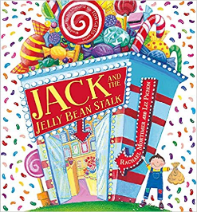  T2/3: suddenly, offered furious cramming thundering | Key text: In the Garden ORT book  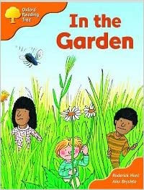  T2/3: glowing, jungle, desert, climbing |  |  |  |  | Continue In the Garden ORT book |  |  | Key text: Seed to Sunflower 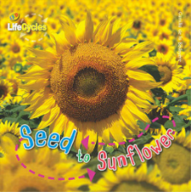T2/3: healthy, spreading, softens, stripes |  |  |  | Continue Seed to Sunflower
Outcomes: past tense verbs.  Suffixes: Use –ing, –ed, –er and –est where no change is needed in the spelling of root  words.  Grammar focus. | Outcomes: Explore children shrinking and exploring the garden with mini pictures of themselves. Think of new problem and resolution for the story. |  |  |  |  | Outcomes: Focus on problems and resolution in retell of their own version of the story. |  |  | Outcomes: Explore the way the book is set out. Answer questions from the text. Make research notes about the life cycle of an apple. |  |  |  | Outcomes:  Information text about the life cycle of an apple.

