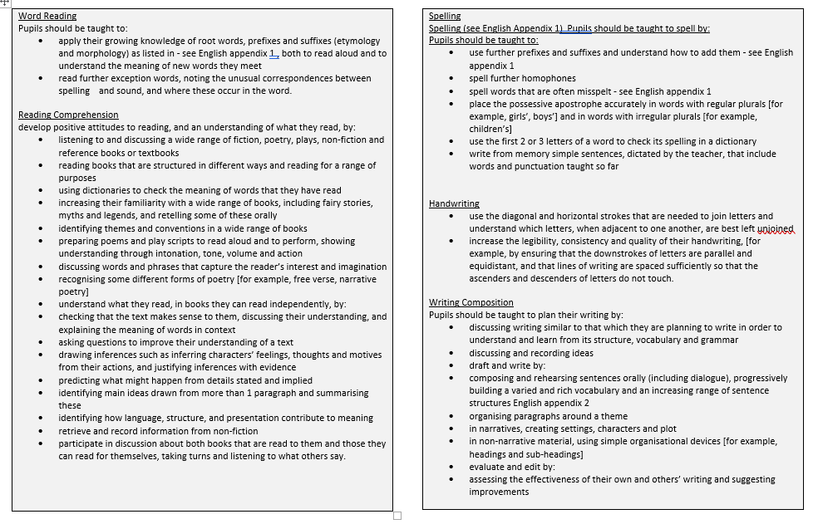

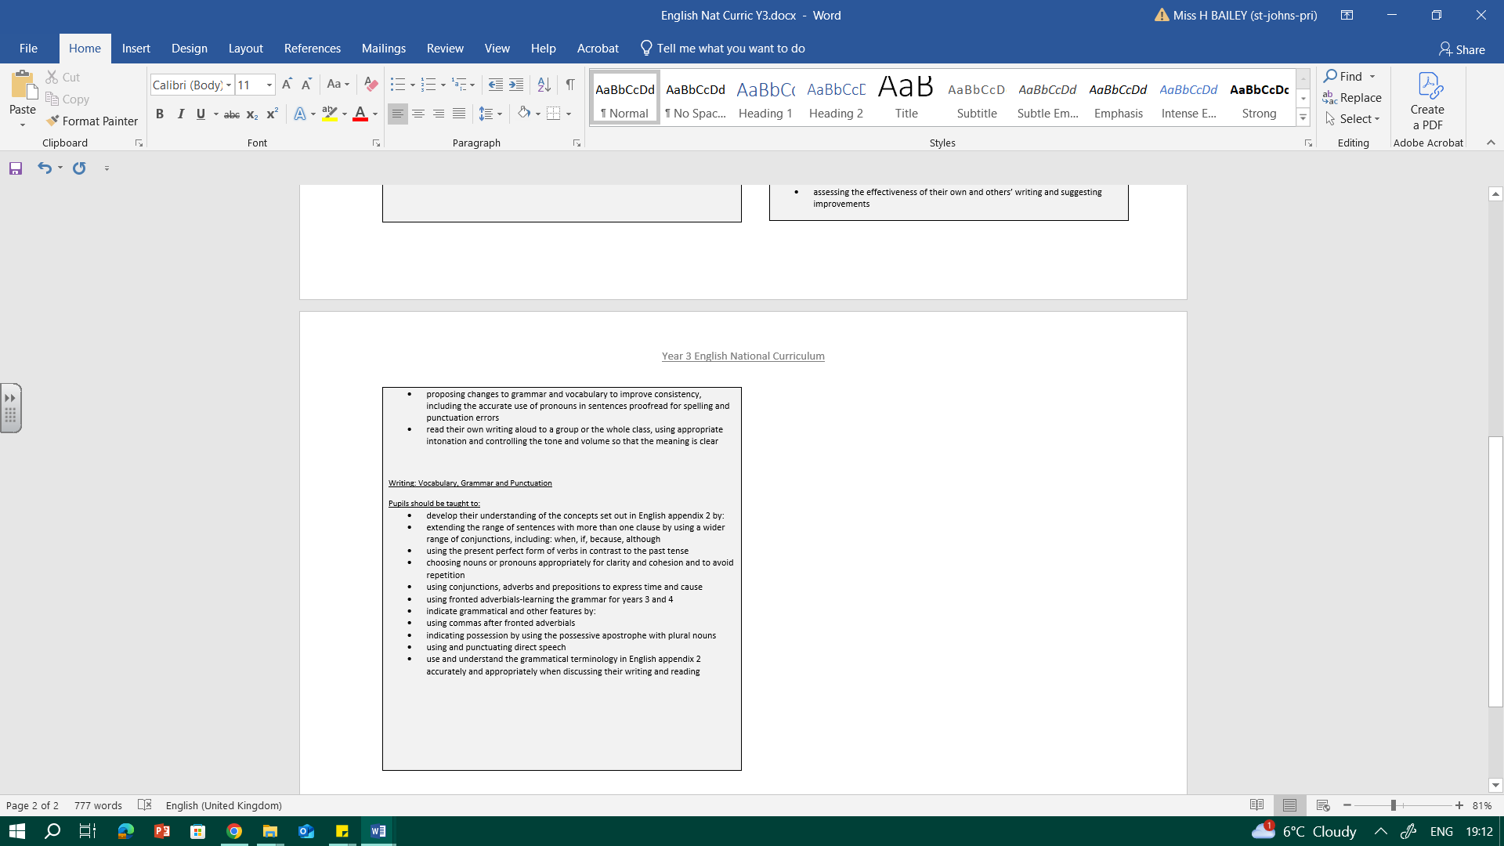

YEAR 3 ENGLISH OVERVIEW
Alan Peat sentences to be taught in English: BOYS Sentences; As –ly sentences; Continues 2AD sentences; __ing, __ed sentence; Double –ly ending
Topic: Amazing Archaeology
Tier 2 vocabulary: wandering, stumble, munch, relief, flickering
Oracy Autumn Term
Physical Oracy:  Deliberately selects gestures that support the delivery of ideas e.g. gesturing towards someone if referencing their ideas. |  |  |  |  | Linguistic Oracy:  Be able to use specialist language to describe their own and others’ talk.
Cognitive Oracy:  Offer opinions that aren’t their own e.g. taking on the role of … |  |  |  |  | Social & Emotional Oracy:  Speak with confidence in front of an audience (CW Year Group Performance)
Week 1 | Week 2 |  |  | Week 3 |  | Week 4 |  |  | Week 5
Key text: Stone Age Boy  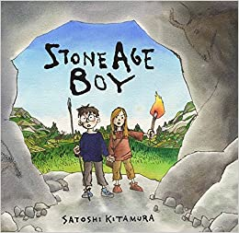 | Key text: Stone Age Boy continued |  |  | Key text: Stone Age Boy continued |  | Key text: Life in the Stone Age, Bronze Age and Iron Age  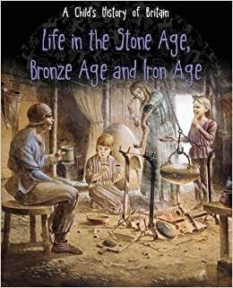 |  |  | Key text: Life in the Stone Age, Bronze Age and Iron Age continued.
Outcomes:  Topic rotation to research the Stone Age, what it is and when it happened.  - Make a clay pot  - Stone Age cooking  - Flint napping  - Cave paintings with natural paint.  Reading:  Inference and prediction based on the front cover of Stone Age Boy.  Focus on the setting descriptions. | Outcomes:  Build own stone age setting. Write setting description for Stone Age Boy. |  |  | Outcomes: Focus on use of fronted adverbials as children continue the retell of the story explaining what they did when they were in the stone age (children to use topic rotation activity ideas in their story) |  | Outcomes: Research about life in the Iron Age for information poster. Children to use the following subheadings.  War and Warriors: Boudica and the Celts against the Romans  Food and Farming: What did they eat and where did their food come from? Cooking stew  Hill forts: Considering British Camp in Malvern, why would this be used as a defensive location? Using historical skills to predict and identify why it would be used as a home. |  |  | Outcomes: Write research into paragraphs for poster.
Topic: Feel the Force
Tier 2 vocabulary: conclusion, results, equipment, method, fair, variable, texture, findings, surface, attracts, motion, direction, travelled, friction
Imperative verbs: use, stick, prop, push, pull
Week 1 |  |  | Week 2 |  |  |  | Week 3
Key text: Electricity and Magnets  Terry Cash & Barbara Taylor  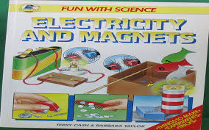  Scientific experiment recount texts |  |  | Key text: Instructional texts |  |  |  | Key text: Instructional texts
Outcomes: Write up science experiment about materials and friction using a text map. Scaffold write using a text map  SPAG: recap a and an determiners. Past tense as experiment already completed. |  |  | Outcomes: Instructions about how to make a compass with a scientific explanation about how it works.  Children to use a text map independently |  |  |  | Outcomes: Independent write. Children to make their own text map to help with writing.  Instructions about how to make a magic pod racer game with a scientific explanation about how it works.
Topic: Genius Geologists
Tier 2 vocabulary: drift, beneath, loom, quiver, beyond faint, preserve, gather, tremendous, curiosity, furious multi-coloured, dull, stripy, streaked, speckled, sparkly, shiny, jagged, crumbly

Week 1 | Week 2 |  |  | Week 3 |  | Week 4 |  |  | Week 5
Key text: Stone Girl Bone Girl  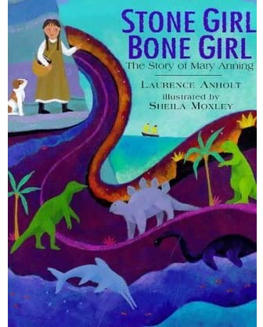 | Key text: Stone Girl Bone Girl continued |  |  | Key text: Escape from Pompeii  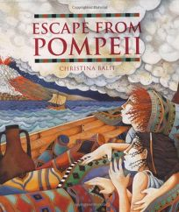 |  | Key text: Escape from Pompeii continued |  |  | Key text: Escape from Pompeii continued
Outcomes: Collect seaside vocabulary to describe the sea, sky, clouds, shells, cliffs etc. Role play finding a fossil using salt dough fossils and sand trays. Retell the story using imovie. | Outcomes: Diary entry as if you are Mary Anning finding a fossil. |  |  | Outcomes:  Reading activities around the story. Visualisation of the setting of Pompeii. Comprehension about the story. Character profiles. |  | Outcomes: Build descriptive vocabulary for an eruption of a volcano. Plan out ideas for retell of the story focusing on the eruption. |  |  | Outcomes: Retell the middle of the story about the eruption.
Topic: Gods and Heroes
Tier 2 vocabulary: hoisted, victims, prevent, cruelty
wagon, rumbles, flings, mighty, prisoners, escape, rose
Oracy Spring Term
Physical Oracy:  Deliberately varies tone of voice in order to convey meaning e.g. speaking authoritatively during an expert talk. |  |  |  |  | Linguistic Oracy:  Use specialist vocabulary e.g. when talking about archaeologists and historians.
Cognitive Oracy:  Begin to reflect on discussions and their own oracy skills and identify areas of strength and areas to improve. |  |  |  |  | Social & Emotional Oracy:  Begin to recognise different roles within group talk e.g. sage and scribe, chair/leader
Week 1 | Week 2 |  |  | Week 3 |  | Week 4 |  |  | Week 5
Key text: Travel brochures for Greece  Read through information and pick out key info https://www.greeka.com/greece-culture/ | Key text: Greek Myths  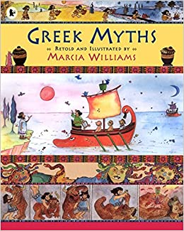 |  |  | Key text: Theseus and the Minotaur continued. |  | Key text: Theseus and the Minotaur continued. |  |  | Key text: Legends Poems- ORT  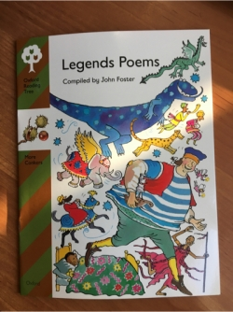
Outcomes: Research about modern day Greece and create an information poster about modern day Greece. This will be a double page poster where the other side will be a comparison about Ancient Greece (this will be completed during topic sessions). | Outcomes: Focus on Theseus and the Minotaur. Artis session for travel through the labyrinth. Collect adverbs to describe how Theseus moved around the Labyrinth. Learn about speech marks to punctuate direct speech. |  |  | Outcomes:  Artis session of Theseus and the Minotaur. Take freeze frame pictures of the different parts of the story. Retell the start of the story. Paired and supported writing. |  | Outcomes: Innovate the story by creating own mythical creature. Describe the character. Retell the middle and end of the story using own mythical creature. |  |  | Outcomes:  Perform the poem aloud using instruments to demonstrate the thunder etc.  Write up your own poem about a Greek God thinking about their symbols and powers.
Topic: You are What You Eat
Tier 2 vocabulary: system, support, develop, sources, provides
variety, sternly, common, disguise, discovery
Week 1 |  | Week 2 |  |  | Week 3 |  |  | Week 4
Key text: Poetry focus Sound Collector by Roger McGough and ‘The Taste-Taker’ by Josie Whitehead |  | Key text: Wanted: The Perfect Pet. Book used as a hook into topic about animals.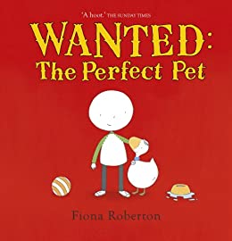 |  |  | Key text: Wanted: The Perfect Pet continued |  |  | Key text: Wanted: The Perfect Pet continued
Outcomes: Read and understand the poem, find features of poem and compare to different types of poems. Children to taste a range of foods and write a taste collector poem based on the sound collector. |  | Outcomes:  Look at persuasion in a general sense. Children to watch persuasive adverts and find features of persuasion. Children to create an advert about the school dinners.  Children to research about their diet, behaviour and environment.  https://www.rspca.org.uk/adviceandwelfare/pets  Children to read and take notes.  Focus on using bullet points and summarising information. |  |  | Outcomes:  Use a range of conjunctions to extend bullet points. Focus on also, although, because, therefore, but, so, or  Organise information about pets into relevant subheadings. |  |  | Outcomes: Plan and write own persuasive leaflet to persuade Henry (from the text Wanted: The Perfect Pet) to buy a specific pet.
Topic: Brilliant Botanists
Tier 2 vocabulary: feathery, winding, inconvenient, gingerly

Oracy Summer Term
Physical Oracy:  Consider position and posture when addressing an audience. (Year Group CW Performance) |  |  |  |  | Linguistic Oracy:  Make precise language choices e.g. instead of describing a cake as ‘nice’ using ‘delectable’.
Cognitive Oracy:  Reach shared agreement in discussions |  |  |  |  | Social & Emotional Oracy:  Adapt the content of their speech for a specific audience
Week 1 | Week 2 |  |  | Week 3 |  | Week 4 |  |  | Week 5
Key text: Mrs Pepperpot stories  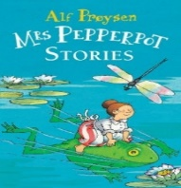 | Key text: Mrs Pepperpot stories continued |  |  | Key text: Mrs Pepperpot stories continued |  | Key text:  Pepperpot stories continued. Clips from Honey I Shrunk the Kids. |  |  | Key text:  Pepperpot stories continued.
Outcomes: Focus on Mrs Pepperpot and the magic wood. Read as a class using active reading to explore the story. Find the meaning of unknown vocabulary. Look closely at the setting description and use visualisation to imagine what the wood would be like. | Outcomes: Explore the ‘Kunkenhoff gardens’ on google earth on the ipads.  Build descriptive sentences about the gardens using paired and shared writing. |  |  | Outcomes: Children to make their own magic garden and use descriptive language independently to start building up a setting description. |  | Outcomes: Children to explore the idea of a narrow escape or near miss and how this can add interest to a story. Children to plan their own story in the style of Mrs Pepperpot with a narrow escape. |  |  | Outcomes: Write story based on Mrs Pepperpot with a narrow escape.
Topic: Empire Strikes Back (Romans)
Tier 2 vocabulary: sweltering, desert, discipline, rebels, plunder
Week 1 | Week 2 |  |  | Week 3 |  | Week 4 |  |  | Week 5
Key text: Spartacus  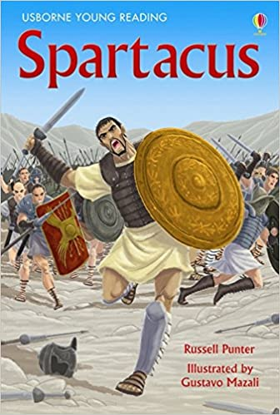 | Key text: Spartacus continued |  |  | Key text:  Spartacus continued |  | Key text: A range of ORT playscripts |  |  | Key text: Speech: “Friends, Romans, countrymen, lend me your ears”  BY WILLIAM SHAKESPEARE  (from Julius Caesar, spoken by Marc Antony)
Outcomes:  Read and explore the story. Collect vocabulary to find the meaning of. Comprehension based on the story. Build a Spartacus fact file. | Outcomes: Artis session based on Spartacus’ introduction. Children to rewrite the introduction focussing on direct speech. |  |  | Outcomes: Look at the features of play scripts. Children to use an Artis session to act out different parts of the story, freeze frame and add speech bubbles. Share write speech bubbles into a play script. |  | Outcomes:  Creating a play script of Spartacus. Focus in on the section of the book where Spartacus escapes. |  |  | Outcomes:  Poetry  Assassination of Julius Caesar. Look at extracts of the William Shakespeare speech “Friends, Romans countrymen lend me your ears” Take apart parts of the poem and try and debate what they think has happened.

