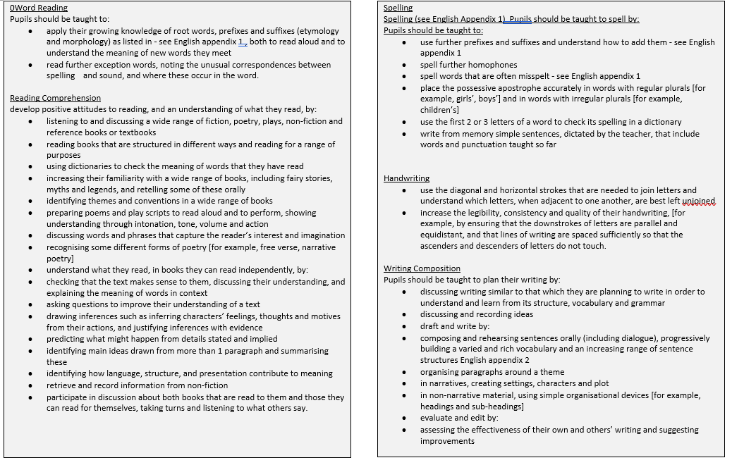

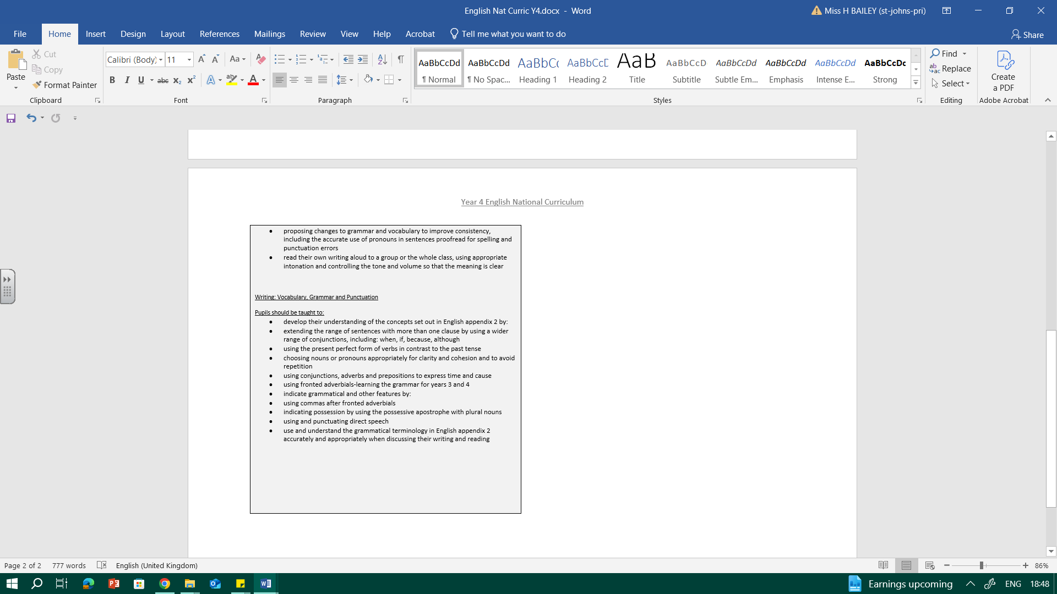
YEAR 4 ENGLISH OVERVIEW
Year 4 Alan Peat sentence types to be taught throughout English: Emotion, comma; verb, person; if, if, if then; With a(n) action, more action; and 3_ed
Topic: Treasure Seekers
Tier 2 vocabulary: slaughter, gape, generations, savage, extinguish, shiver, stench, plunder
Oracy Autumn Term
Physical Oracy:  Deliberately select movement and gesture when addressing an audience. (Year Group CW Performance) |  |  |  | Linguistic Oracy  Carefully consider the words and phrasing they use to express their ideas and how this supports the purpose of the talk e.g. to persuade or to entertain.
Cognitive Oracy:  Give supporting evidence e.g. citing a text (using sentence stems) a previous example or an historical event |  |  |  | Social & Emotional Oracy:  Use more natural and subtle prompts for turn taking
Week 1 | Week 2 |  | Week 3 |  | Week 4 |  | Week 5
Key text: Kennings | Key text: Kennings continued |  | Key text: Beowulf  https://www.youtube.com/watch?v=QKjco FZmKuA |  | Key text: Beowulf |  | Key text: Beowulf
Focus The  Ruin |  |  | 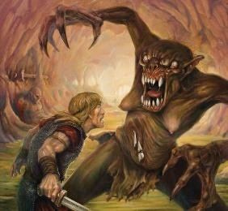 |  | continued |  | continued
Outcomes:  Initial  assessment  based on Roman prompt.  Read/  perform  poems  Analyse  poems  Language  work  including  identify word  Types | Outcomes:  Well-chosen nouns/ alliteration/ rhyme – using rhyming dictionaries.  Scaffolded kenning about a warrior.  Independent kenning about weapons.  Publish kennings on weapons |  | Outcomes:  Read a range of myths  and Beowulf stories.  Retell stories using Talk 4  Writing story map. Collect vocabulary/ ideas. |  | Outcomes: Apply vocabulary (well chosen nouns/ adjectives fronted adverbials)  - Apply figurative language e.g. similes and alliteration/ metaphors through kennings) Plan innovation story. |  | Outcomes:
 |  |  |  |  |  |  | Improving
 |  |  |  |  |  |  | work.
Independent
plan. Editing and improving .
Topic: Junior Medics
Tier 2 vocabulary: crucial, decay, vital, cavity, essential, provide, undeniable, experts, reduce, increase
Week 1 |  | Week 2 |  | Week 3 |  | Week 4
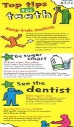  Key text: Persuasive leaflets (Oral B, Change 4 life)  Outcomes:  Read a range of leaflets  Collect features of a leaflet.  Collect persuasive features. |  | Key text: Persuasive leaflets (Oral B, Change 4 life) continued  Outcomes: Collect features of a leaflet.  Collect persuasive features.  Summarise texts to collect research notes  Subheadings |  | Key text: Persuasive leaflets (Oral B, Change 4 life) continued  Scaffolded writing Sentence types: if, if, if, then  Healthy eating poster |  | Persuasive leaflets (Oral B, Change 4 life) continued  Planning and writing a persuasive leaflet about looking after your teeth.  Edit and improve.

Topic: Raiders
Tier 2 vocabulary: vicious, raid, brandish, conquer, warrior, plunder, honour
Oracy Spring Term
Physical Oracy:  To use pauses for effect in presentational talk e.g. when telling an anecdote or joke. |  |  |  | Linguistic Oracy  Carefully consider the words and phrasing they use to express their ideas and how this supports the purpose of the talk e.g. to persuade or to entertain.
Cognitive Oracy:  Ask probing questions |  |  |  | Social & Emotional Oracy:  Start to develop empathy with an audience
Week 1 | Week 2 |  | Week 3 |  | Week 4 |  | Week 5
Key text: Freya and the Goblins (adapted by Nigel Bryant). | Key text: Freya and Goblins continued |  | Key text: Freya and Goblins continued |  | Key text: The Vikings in 30 Seconds  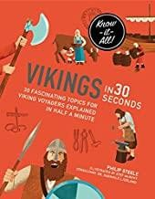 |  | Key text: The Vikings in 30 Seconds continued
Outcomes: | Outcomes: |  | Outcomes: |  | Outcomes:  Listen to/read Viking sagas about the gods.  Learn a model text about a Viking god using Talk 4 writing.  Story map text. Rewrite model text |  | Outcomes: Research own god/goddess Draw picture and label.  Practice sentence types from model text. Fronted adverbials.  Apostrophes.
Plan/story map
own paragraph
 |  |  |  |  |  |  | Write up own text. Illustrate.
Topic: Electrical Engineers
Tier 2 vocabulary: brink, swayed, snag, patch, peeping, peering, craned
Week 1 |  | Week 2 |  | Week 3 |  | Week 4
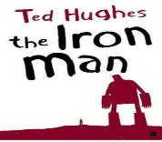  Key text: The Iron  Man  Outcomes:  Topic week for subject knowledge  Reading: Iron Man Give/explain the meaning of words in context |  | Key text: The Iron  Man continued  Outcomes: Saffolded/shared character descriptions of the Iron Man |  | Key text: The Iron  Man continued  Outcomes: Scaffolded/shared setting descriptions |  | Key text: The Iron Man  Continued  Outcomes:  Write own retell of the Iron Man thinking about characters and setting.

Topic: Super Sonologists
Tier 2 vocabulary: pitch, volume, dynamics, high, low, loud, quiet, vibration, length, era, compose, yowling
Week 1 |  | Week 2 |  | Week 3 |  | Week 4
Key text: The Story of the Orchestra  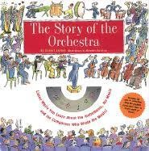 |  | Key text: The Story of the Orchestra continued |  | Key text: The Story of the Orchestra continued |  | Key text: The Story of the Orchestra continued
Outcomes:  Reading: The Story of the Orchestra  Read other non-fiction looking at layout, paragraphs, headings, subheadings. |  | Outcomes: Focus on a string instrument and discuss how to change the pitch and volume. Learn model Talk 4 writing text. |  | Outcomes: Sentence types:  Alan Peat, if, then Subordinate clauses/fronted adverbials. |  | Outcomes:  Plan explanation text about own instrument. Write explanation text and peer assess.
Topic: Wild Water
Tier 2 vocabulary: Vocab: frolic, shimmer, determined, immense, emerge, dappled, glints, drench
Oracy Summer Term
Physical Oracy:  Use the appropriate tone of voice in the right context. |  |  |  | Linguistic Oracy  Carefully consider the words and phrasing they use to express their ideas and how this supports the purpose of the talk e.g. to persuade or to entertain.
Cognitive Oracy:  Reflect on their own oracy skills and identify areas of strength and areas to improve and begin to set own targets |  |  |  | Social & Emotional Oracy:  Consider the impact of their words on others when giving feedback
Week 1 | Week 2 |  | Week 3 |  | Week 4 |  | Week 5
Key text Outcomes:  Science focus-  Science  Labelled diagrams  Writing up science  investigations | Key text: Hook book- The River: An Epic Journey to the Sea  Outcomes:  Research and  take notes about  rivers. Organise  information into subheadings. |  | Key text: Outcomes:  double page  spread non-fiction  report on rivers. |  | Key text: The Snail and the Whale, Lila and the Secret of the Rain and Zahra  https://www.literacyshedplus.c  Outcomes:  Explore journey  stories (see  above) Use a talk  2 writing map to learn a simple  story about the  journey of a fish. |  | Continued  Outcomes: Learn  about speech and  adverbials. Edit  and add detail to  the story to retell own fish story.

Topic: Environmental Engineers
Tier 2 vocabulary: blazing, thirst, scorching, beat, drought, billowing, cascade
Week 1 | Week 2 | Week 3 | Week 4 | Week 5
Key text: https://www.lite racyshed.com/t he-inspiration- shed.html | Key text: https://www.wateraid  .org/uk/  Water Aid adverts | Key text: | Key text:  The Literacy Shed: Other Cultures Shed: ZAHRA-  Visual literacy. https://www.literacys hed.com/the-other- cultures-shed.html | Key text:
The Cloud
that was
Made of
More- Visual
literacy.
Outcomes: | Outcomes: Focus on | Outcomes: Using | Outcomes: | Outcomes:
Discussion | emotive language. | images from Water Aid, | Explore the | Write a
about |  | children create | story. Answer | letter to the
personificati |  | emotive, persuasive | questions about | government
on. Go |  | posters. | inferences from | to support
outside and |  |  | the story. | the finding
go cloud |  |  | Explore the | of water
spotting. |  |  | features of | supplies in
Children to |  |  | letter writing. | Africa.
explore the
life of a
cloud using
knowledge
of the water
cycle.

