Useful websites for new to English children, where they can access stories, games and activities in some home languages (Arabic, Spanish etc) and English at home or at school
British council – learn English online: https://learnenglishkids.britishcouncil.org/
https://learnenglishkids.britishcouncil.org/games
Children’s books online:
http://www.childrensbooksonline.org/library-translations.htm
Cambridge English -
https://www.cambridgeenglish.org/learning-english/parents-and-children/activities-for-children/

Examples of activities:
https://www.cambridgeenglish.org/learning-english/activities-for-learners/a1r004-meeting-people-for-the-first-time
https://www.cambridgeenglish.org/learning-english/activities-for-learners/a1r056-which-animal

You Tube videos to support learning about the body, family, days of the week, feelings and more:
https://www.youtube.com/watch?v=hFIGwwE1uAM
https://www.youtube.com/watch?v=3tx0rvuXIRg
https://www.youtube.com/watch?v=ql9-75jhQxE
https://www.youtube.com/watch?v=8irSFvoyLHQ

Short stories to listen to in English (Jungle book, Alice in Wonderland etc)
https://www.youtube.com/watch?v=gjfJcgHdeUQ
https://learnenglishkids.britishcouncil.org/es/short-stories
https://storylineonline.net/
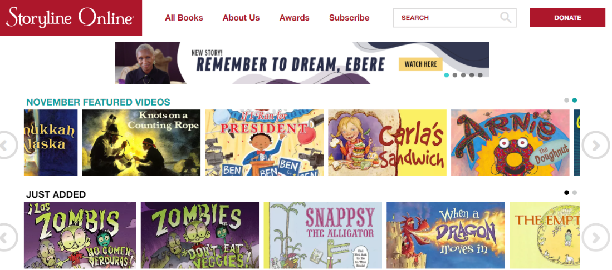

Read a book in home language:
http://en.childrenslibrary.org/
http://en.childrenslibrary.org/library/books_by_language.html

