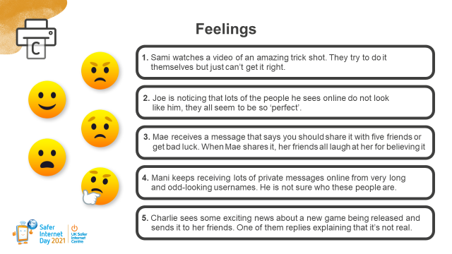

Choose one of the situations above and pretend you’re their friend.
Write your friend an email, giving them advice and making them feel better.

Dear Sami,
I know you’ve been working really hard to get that trick shot right – it’s crazy right?! I wouldn’t worry if you can’t you can’t do it – it’s probably not real anyway. Did you know that these people use camera tricks and editing to make impossible things look real? It’s probably a fake.
Why don’t you ask your Dad what he thinks? He might be able to give you some tips.
Play Among us later?
Tx

