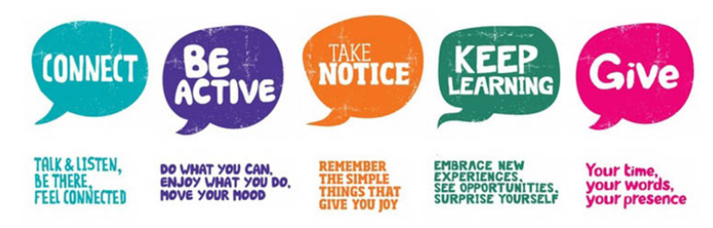

Look after your mental health. Choose one activity to complete every day during Children’s Mental Health week 1st – 7th February 2021. Express yourself.
Take notice  Play with playdough (or plasticine) and see what you can make. While you’re playing, notice what it feels like.  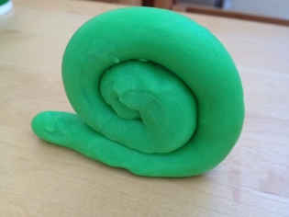  Here’s a recipe for making your own playdough: https://www.bbcgoodfood.com/howto/guide/playdough-recipe | Be active  Create a family band!  Make some musical instruments and use them to make some music. Record yourself and share with us!  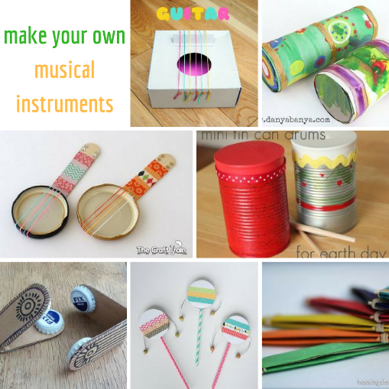  https://redtri.com/homemade-instruments/slide/1 | Be active  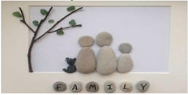  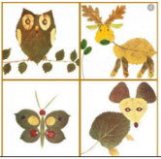  Go for a walk around the local area. Collect leaves and sticks and other natural items. Try and create your own natural art. | Take notice  Turn your squiggles and doodles into amazing art!  The Squiggle Game  https://www.youtube.com/watch?v=ozKW1M97JXE&feature=youtu.be
Connect  Random Acts of Kindness  Can you show an act of kindness today?  For more ideas - Scroll to the bottom where you’ll find socially distanced kindness resources. Find an idea you like.  https://www.randomactsofkindness.org | Be active  Get the whole family together for some yoga to exercise your body and calm your mind.  Choose something that inspires you: superheroes, Moana or Jungle safari!  https://cosmickids.com/watch/ | Keep learning  Make a family portrait!  Use what you can find around the house – a mop for hair? Bananas for fingers?  Can you name the body parts or even the organs inside?  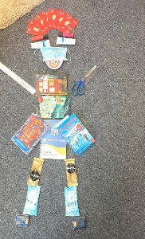 | Connect  Make a Time Capsule.  These are memorable times that will also be part of history. Put together a time capsule of things that will remind you of this time:  - A picture or photo  - A diary of a lockdown day  - A recipe you have enjoyed  - A newspaper article  Put everything in a box or large plastic bottle and decorate a label for it.  When will you open it up? On your 18th birthday? In 2041?
Take notice  Sit quietly, close your eyes and listen. List all the things you can hear – to the tiniest sound.  Could you hear the wind? Have a go at making a wind chime.  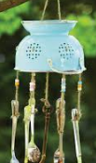  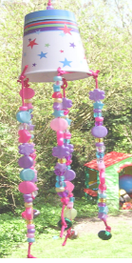  https://bigdiyideas.com/40-simple-diy-projects-for-kids/ | Take notice  In an increasingly busy, over-connected world, it is more important than ever to take time for yourself - this rings true for adults and kids alike!  Mindfulness can help you be present in the moment and appreciate every little thing.  https://www.headspace.com/meditation/kids  https://www.youtube.com/watch?v=4vDxcUK9v9k | Give Connect  It seems a long time since we have been together so why not decorate a heart and write a message to your classmates and teachers. Make the heart and then take a picture of it, on its own or you holding it to the camera and share it with us  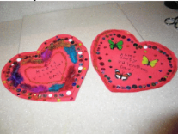 | Keep learning  Set yourself a baking challenge!  - Cook something you’ve never made before  - Follow a recipe  - Measure out ingredients  - Present it beautifully and send us a picture!    bakingmad.com/recipes/kids-baking

