Find and tick 2 x 5 = 5 x 2
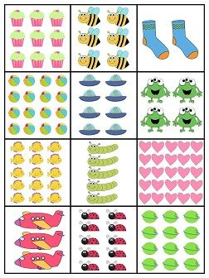

Find and tick 2 x 4 = 4 x 2

Find and tick 3 x 2 = 2 x 3

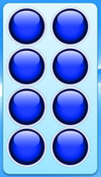
Complete the number sentences to describe the arrays.


4 x 2 = ___ x ___ 2 x 6 = ___ x ___

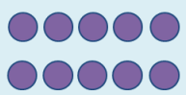
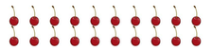

2 x 10 = ___ x ___ 5 x 2 = ___ x ___

Use 6 cubes, how many arrays can you create?
Once you have created your array complete:

___ x ___ = ___ x ___ ___ x ___ = ___ x ___

