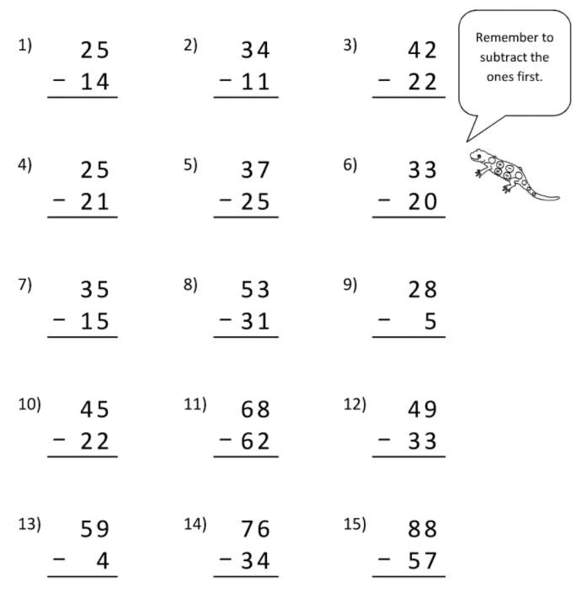
LO: To use the column method for 2 digit subtraction

