Does chocolate grow on trees?
Our topic from now until Christmas holidays is Does chocolate grow on trees? These are some of the homework tasks that you can complete over that time. Choose some you’d like to do and write the date when you’ve completed them.
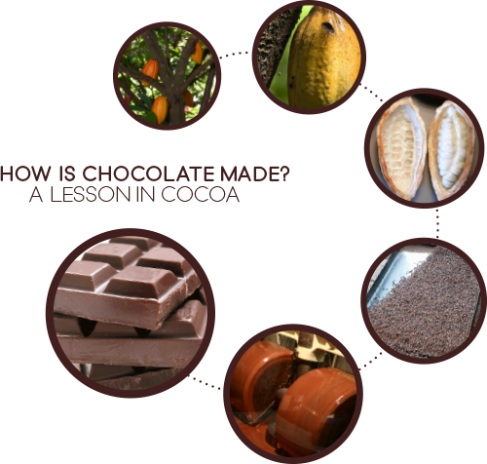
Homework Tasks | Date
Find out and write about how chocolate is made.
Who were the Aztecs?
Design your own chocolate bar
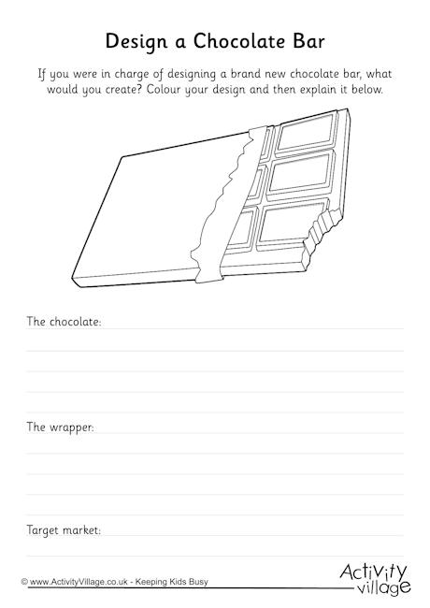
Design your own Aztec mask.
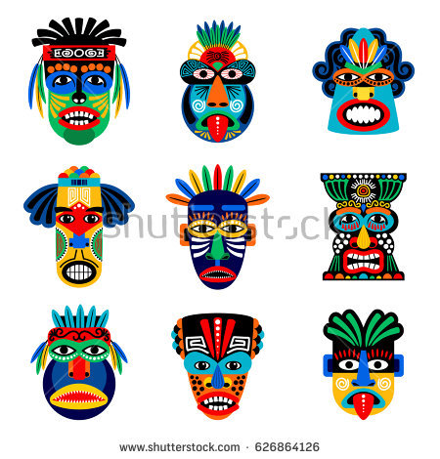
Find a recipe and make a chocolate treat.
Design your own chocolate monster. 
Design your own chocolate factory.
Write a poem about chocolate.

