History Key Facts Aztecs
- The Aztecs were an ancient civilisation, a people group who lived in modern day Mexico City from AD 600 to AD 1524.
- It is difficult to find information about the Aztecs because they were an Ancient Civilization, but ancient Aztec masks, manuscripts, ruins and artefacts found by archaeologists can tell us somethings about Aztec life.
- Aztecs gave the world many inventions: chocolate, medicine, gum, guacamole and the calendar.
- The Spanish invaders eventually brought cacao and drinking chocolate to Europe, where it was later developed.
History Key Facts The Cadbury Family
- When looking at Cadbury 1824 – 1900s and the Aztecs, it is the past beyond living memory because no one who remembers it is still alive. We have more evidence that tell us about the Cadbury family (photographs, documents) because they lived much later than the Aztecs.
- John Cadbury opened his first shop in Birmingham in 1824, in 1847 he opened a factory to produce drinking chocolate.
- In 1878, the Cadbury family moved the factory to Bournville. There, Richard and George Cadbury (John’s sons), built a swimming pool, a park, tennis courts and a bowling green. They gave their workers time off and their Quaker faith helped them to care for the people in the village they built.
- Cadburys chocolate continued to develop to modern day, and today you can visit Cadbury World in the same factory in Bournville.
History Vocabulary
- History beyond living memory – no one who was there at the time is still alive.
- Sources tell us things about people, places events in the past.
- Ancient Civilisation - a group of people a very long time ago who built a way of life.
- An Empire is a group of people under one person’s or group’s leadership.
- An artefact is something that was made by man, and found from the past.
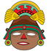 | Aztec Timeline
Date (AD) | Event
600 | The first settlers arrive in Mexico  A people who spoke Nahuatl arrived in Mexico and settled in.
1100 | The Mexicas arrive in Mexico  A people called the Mexica arrived in Mexico and began looking for a place to settle.
1325 | 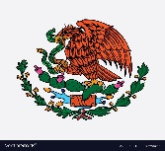  Tenochtitlan was the capital and founded because the Aztec god Huitzilopochtli commanded his people to settle where they found an eagle perched on a cactus, eating a snake.
1350 | Ways to travel are built  The people worked together to build water canals and other causeways.
1390 | The building of a temple begins  The people began working to build the Templo Mayor, or the Great Temple.
1492 | Christopher Columbus landed in Santa Domingo  Christopher Columbus landed in the New World, brining other explorers behind him.
1502 | Montezuma II steps into power  Montezuma II was the most famous of the Aztec kings.
1521 | The Aztecs meet their end  The Spanish soon took over Tenochtitlan. The Aztec king was killed shortly after this, and the Spanish set up their own rule, calling it New Spain. It was the end of the Aztec people.
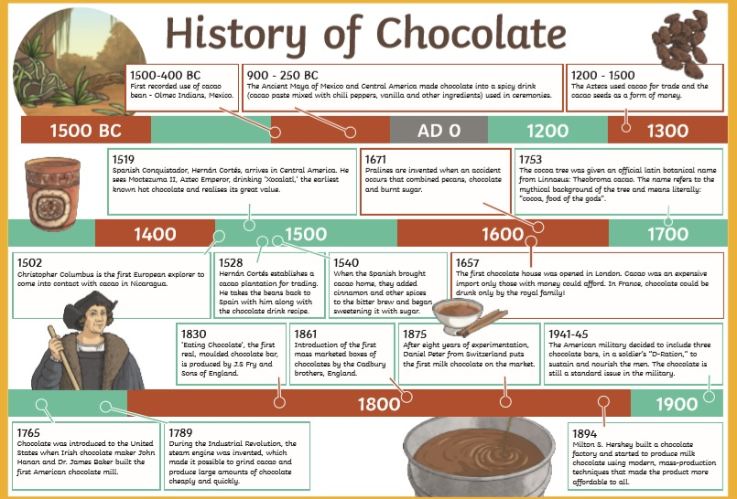
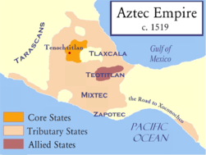
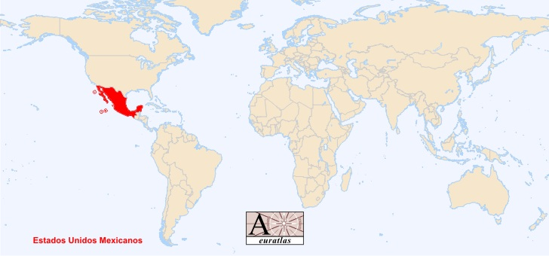
Geography Key Facts Mexico
- Modern day Mexico is a country in the continent of North America.
- The seas around Mexico are the Gulf of Mexico and the North Pacific Sea.
- Tenochtitlan was only a small piece of land on Lake Texcoco in the Valley of Mexico. Surrounding it was a freshwater lake, along with some swampy marshes.
- The climate in Tenochtitlan was about 12 C. In the winter time, the temperature was really cold, and sometimes developed frost.
- Aztecs built a system of canals and causeways that supplied the hundreds of thousands of people who lived there. They also built floating gardens called Chinampas, where they grew vegetables.
- Close to the ancient city of Tenochtitlan is the modern day capital of Mexico, Mexico City but the lakes have dried up and it is sinking now!
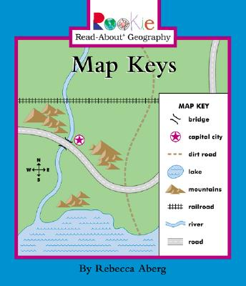
Geography Key Facts Bournville
- A map of present day Bournville and a map of Bounville in 1905 show how different the village is now.
- A key on a map has symbols to show what they things on the map are.
Geography Vocabulary
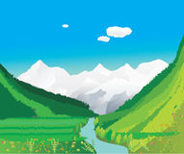
- A valley is a low area of land between hills or mountains, typically with a river or stream flowing through it: It Is a physical feature because it is not man made.
- A marsh is a piece of soft, muddy and wet land, usually with grasses.
- Climate means how hot or cold a place is over a long period of time.

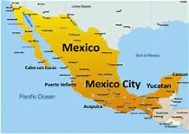
Modern Day Mexico
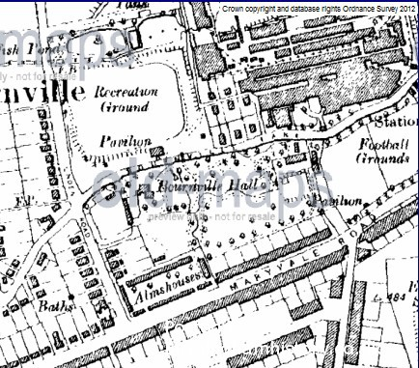

Bournville Map from 1905

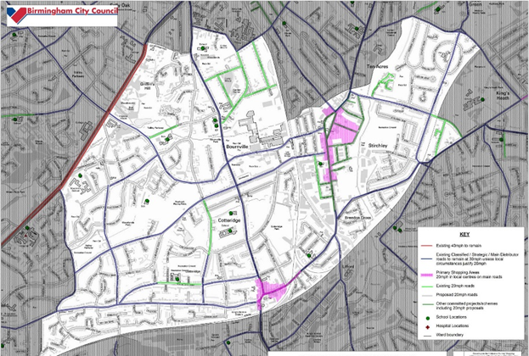

Modern Bournville map

